IBM Cognos 10.2.1 Report Studio

Introduction

This document introduces you to IBM Cognos Report Studio. Through its web portal, the IBM Cognos Connection, Report Studio lets you create and manage complex reports, define layouts and styles, and much more. It offers flexibility in calculating and in formatting report data. With Report Studio you can
- Author complex reports using your data.
- Save and reuse reports.
- Run reports in a variety of formats.
- Print reports.
- Create report templates.
- Manage reports.

Prerequisites

To use this training material effectively, you should be familiar with your department’s data. This training is designed to familiarize you with the IBM Cognos Report Studio reporting tool; it is not designed to familiarize you with the underlying data in UD’s system. The training is based on data in a demonstration database.

Important Note
This training document was designed originally to be used in a class setting. Therefore, the exercises are meant to be followed in a sequence. If you have difficulty working through an exercise, try the first four exercises to familiarize yourself with the basics.

Prepare Your Browser to Use the IBM Cognos Connection Web portal

IBM Cognos 10.2.1 at UD works best using the Windows Operating System running Internet Explorer, version 8 or 9. To use IBM Cognos 10.2.1, you must have cookies and JavaScript enabled. You must also enable ActiveX support. To do this:

- In Internet Explorer, from the Tools menu, select Internet Options.
- On the Security tab, click Custom Level.
- In the Security Settings dialog box, scroll to the ActiveX controls and plug-ins settings and enable Run ActiveX controls and plug-ins and Script ActiveX controls marked safe for scripting.
- Scroll to the Scripting settings and enable Active scripting.
- Scroll to Allow programmatic clipboard access and click Enable.
- Click OK.

Training Objectives

After you complete the exercises in this training material, you should be able to do the following:

- Open the IBM COGNOS Connection web page.
- Open Report Studio.
- Create a report.
- Choose the package for the report.
- Choose one of Report Studio’s predefined templates (list, crosstab, chart, etc.) for the report.
- Add query items to the report.
- Save the report.
- Run the report.
- Recognize the types of reports.
- Change the appearance of reports.
- Create crosstab reports.
- Use charts.
- Filter, sort, and group data.
- Add prompts.
- Perform calculations.
- Create Drill-Through reports.
- Create reports from scratch.
- Add styling.
- Understand how reports are structured.
- Create a Master-Detail report.
- Use Query Explorer to Modify Aggregation Properties.
- Create a report template.

Table of Contents

The IBM Cognos Connection Web Site 5
Exercise 1—Open the Cognos Connection Web Site.

Open Report Studio 6
Exercise 2—Open Report Studio and Begin a New Report.
The Report Studio Window 8

Report Terminology 9

Add Data to a Report 10
Exercise 3—Add Data to a Report and Save It.

Run the Report 13
Exercise 4—Validate and Run the Report.

Types of Reports 15

List Reports 16
Grouped List Reports 16
Exercise 5—Create a Grouped List Report and Set the Group Span.

Create Repeated Form Frames from a List 20
Exercise 6—Create Repeated Form Frames from a List.

Crosstab Reports 23
Exercise 7—Create a New Crosstab Report.
Exercise 8—Create a Crosstab Report from an Existing Report.

Charts 30
Exercise 9—View the Types of Report Studio Charts.
Create a Chart 31
Exercise 10—Create a Column Chart.

Manipulate Data in Reports 37

Filters 37
Exercise 11—Add a Filter.
Exercise 12—Disable Filters.
Filter on Details and Summaries 44
Exercise 13—Filter on Details.
Exercise 14—Create a Summary Filter.

Filter Crosstabs 54
Exercise 15—Filter a Crosstab Report.

Prompts 58
Exercise 16—Add a Prompt.
Exercise 17—Use the “Build Prompt Page” Tool.
Optional Prompts 70
Exercise 18—Add an Optional Prompt.
Drill Throughs 73
Exercise 19—Create a Target Report.
Exercise 20—Create a Parent Report with a Drill Through.
Report Layouts 80
Exercise 21—Create a Report Layout.
Exercise 22—Create a Crosstab Report from Scratch.
Advanced Techniques 89
Exercise 23—Change the Organization of a List Report.
Exercise 24—Add Styling at a Higher Level.
Exercise 25—Format a Crosstab Report.
Report Studio Queries 98
Exercise 26 Use Query Explorer to Modify Aggregation Properties.
Master-Detail Reports 104
Exercise 27—Create a Master-Detail Report.
Exercise 28—Add a Filter to a Master-Detail Report.

Create a Template 108
Exercise 29—Create a Report Template.

The IBM Cognos Connection Web site

► Before you can use IBM Cognos Report Studio; you must know how to open the IBM Cognos Connection web site.

Exercise 1—Open the IBM Cognos Connection Web Site

- Open the Internet Explorer web browser.
- To access the IBM Cognos Connection web site, type the following URL in the browser’s Address field and then press ENTER:
https://cognos.udel.edu/

- Type your UDelNet ID in the appropriate field.
- Type your password in the appropriate field.
You should see a window similar to the following:

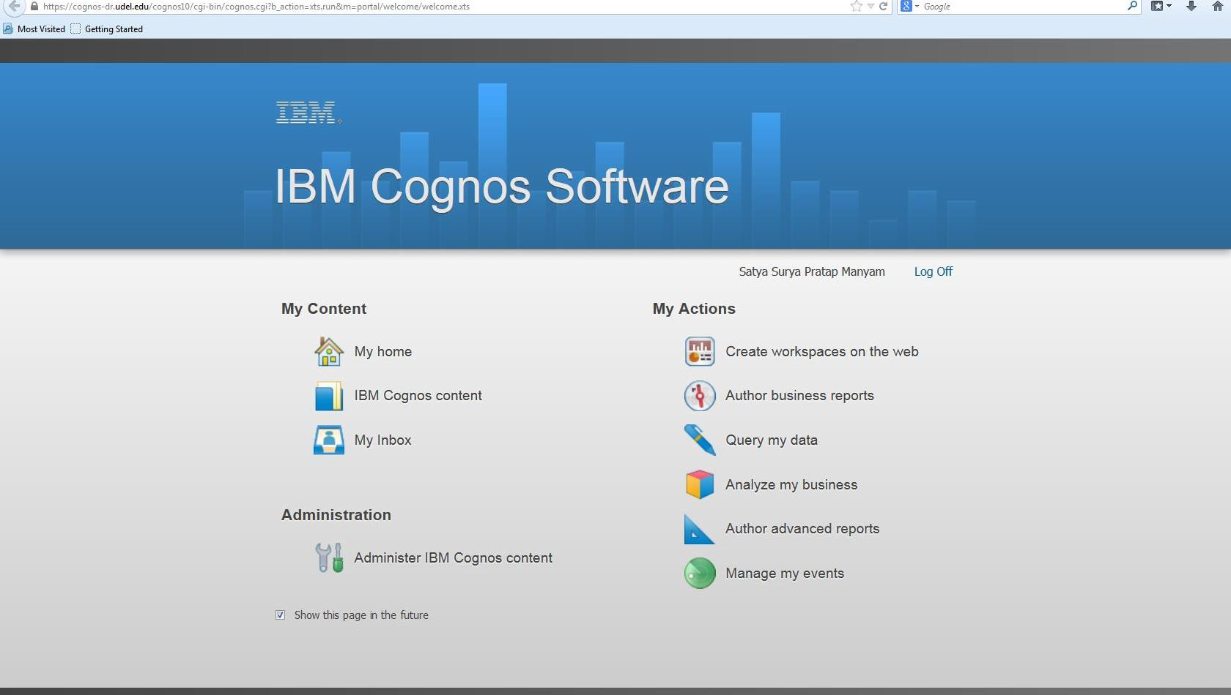

The IBM Cognos Connection web site gives you access to the reporting tools in Report Studio. Report Studio allows you to author complex reports based on your business needs. Reports can contain multiple report objects: lists, charts, and crosstabs as well as images, logos, and other elements.

End of Exercise #1

Open Report Studio

►In the following exercise, you will open Report Studio and begin to create a new report. It is also possible to open an existing report (this will be discussed later).

Exercise 2—Open Report Studio and Begin a New Report
- On the IBM Cognos Connection Web Site Welcome screen, click 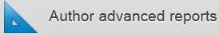
You should see the Select a package window, similar to the following, which contains the packages you can use:
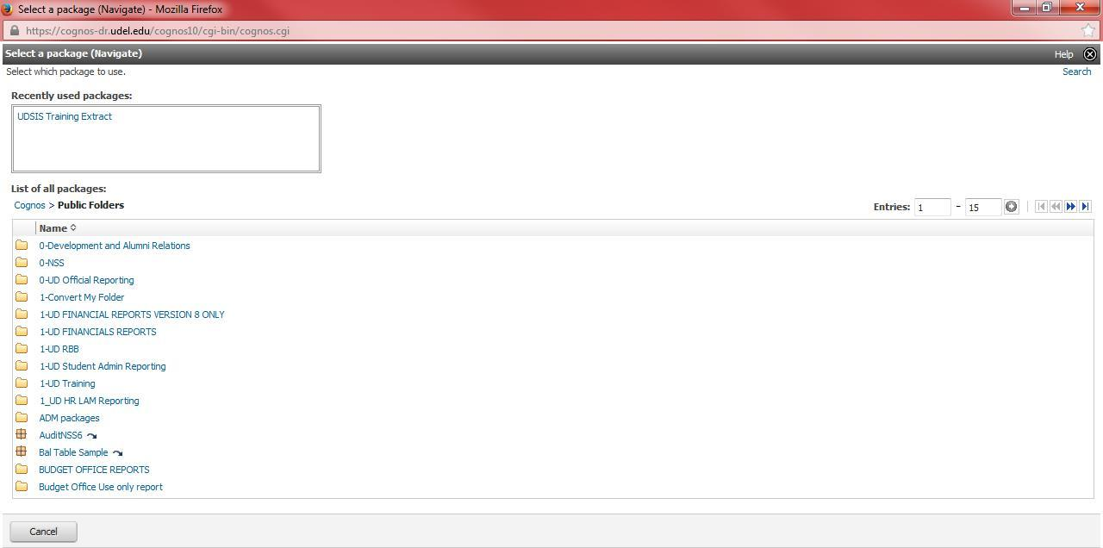
Note: After you have used a package, it will be listed in this box and you can select it from here.

- Find and click UDSIS Training Extract (the listing is in alphabetical order).
    - If you don’t see this package listed, click the arrow to go to the end of the list.

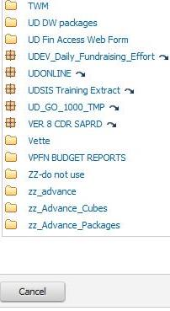
Note: Before you can create a report, a UD Cognos administrator must create a package that contains the data you will work with.

A package is a group of related data elements and data tables (designated by blue folder icons.)

You will learn the name of the package that contains UD data from the UD Cognos administrator.

Before the Report Studio opens, you may see a pop-up block notice like this. Click options and edit the pop-up blocker options. Allow and close both the windows. Repeat step 2

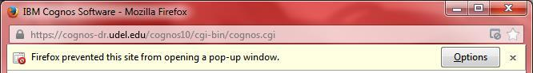

- You will then see a window similar to the following:
- In the Welcome box, click Create new
This brings up a box with a list of layout objects you can use to create your report:

- Click List to select a list report and click OK.

You will see a window like this.
Work Area
Insertable Objects Pane

Explorer Bar

Properties Pane

End of Exercise #2

The Report Studio Window

The Report Studio window contains an Insertable Objects pane, a Properties Pane, an Explorer Bar and a Work Area. A toolbar above the panes allows you to carry out many functions by clicking an icon; there is also a menu bar at the top of the window with a variety of Report Studio commands. Following is a description of the areas of the Report Studio window:

Insertable Objects pane

The Insertable Objects pane at the top left of the Report Studio window contains objects that you can add to your report. There are three tabs—indicated by icons—in this pane:

- The Source tab contains data items you can add to your report from the package you are using.
- The Data Items tab describes the queries you are creating in your report.
- The Toolbox tab contains other objects you can add to your report like text, calculations, hyperlinks, images, and more.

Properties Pane

The Properties pane at the lower left of the Report Studio window lists properties you can apply to a given item in a report. You will work with the Properties pane later in this class.

Explorer Bar

The Explorer Bar, the vertical bar at the center of the Report Studio window, contains three buttons:

- The Page Explorer lets you navigate to a specific report page or prompt page.
- The Query Explorer lets you create or change report queries.
- The Condition Explorer lets you work with variables.

Work Area

Report Studio’s right pane is the Work Area, the space where you create your reports.

Report Terminology

Before you begin to use Report Studio, you should understand the terminology associated with its reports. Each report has two aspects:

- Layout
- Queries

The report layout defines your report’s formatting and appearance. Based on your needs, your report can contain objects such as lists, crosstabs, and charts. It can be formatted to include such features as color backgrounds, images, dates, and more. You also have control over how the data appears on multiple-page reports.

The pages in Report Studio contain the objects you include in your report. Each page must have a page body. It can also have a header and footer.

Report queries control the data items in your report. The simplest queries are created by adding report items from the package you are using. However, complex queries can contain filters, calculations, grouping and more. You can change the queries Report Studio creates as well as create custom queries.

Add Data to a Report

The query items you add to your report appear on the Source tab of the Insertable Objects pane in the Report Studio window. To insert a query item, you can either double-click the item or click the item and drag it into the report. You can use CTRL-click to insert multiple items; items will appear in the order in which you select them. A bold black bar in the work area indicates where you can place query items.

►In the following exercise, you will create a report that shows the majors available for every type of student at the University. To do this, you will first add data to your report and save it.

Exercise 3—Add Data to a Report and Save It

- On the Source tab of your list report, click the plus sign to expand the UDSIS Training Extract item.
Category columns appear in the order in which you select them.
- Click CAMPUS.

- Hold down the CTRL key and click Student_Type.
- Continue to hold down the CTRL key and in the Program item, click MAJOR1.
- Drag the selected items to the work area and release the mouse button when you see the bold black bar.
You will see a window like the one below:
Notice that no data appears in the report yet. You must run the report to see the data.
Note: There are two other ways to insert data into your report:
- Double-click each item to insert it into the report. Items are added to the right side of the report.
- Drag an item into the work area.

You can obtain information about your report’s structure and the items it contains by selecting some of the other tabs and features in the window:

- Click the title of the CAMPUS column.
This produces a list of properties like the one below in the Properties pane at the lower-left of the Report Studio window:
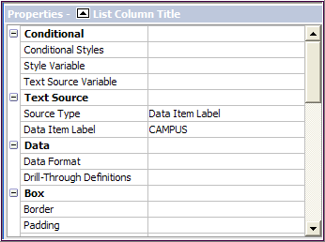
This is a partial list; scroll down to see the remaining properties available to apply to the CAMPUS column.
Note: When you select a property, you will see a description of what it does at the very bottom of the pane. If the description is not visible, go to the View menu, select Panes and then Property Descriptions to display it.

- In the Insertable Objects pane, click the Data Items tab to see the structure of the query Report Studio has created from your items:

- Move the mouse pointer over each of the components of the Explorer Bar in the center of the window to see the type of information each provides.
Next, you will save your report.
- On the File menu, click Save As. You will see a box like the one below:
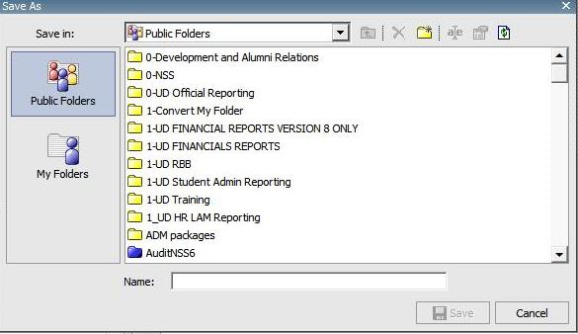
- Click My Folders and in the Name box, type your initials Major List. Click Save.

End of Exercise #3

Run the Report

After you create a report in Report Studio, you must run it to see the actual data. Report Studio offers a tool to validate the report before you run it to make sure it contains no errors. This will be important when you develop complex reports with features such as calculations.
In the next exercise, you will validate the Major List report and then run it to see the data it contains.

Exercise 4—Validate and Run the Report

- In the Major List report, click the Validate Report button in the toolbar (near the Run button).
You will see a prompt page like the one below that requires you to select an Academic Term, click the Reprompt button, then select a Run Date ID and click OK at the bottom of the page.
After clicking the Reprompt button, select a RUN DATE ID.
Select an Academic Term then click the Reprompt button.

- In the Academic Term box, click 2008 Fall Semester, click the Reprompt Button above, and select a Run Date ID, then click OK at the bottom of the page.
You will receive a message that the report is being validated, followed by a box indicating whether the report specification is valid. Click OK to close the box.

- On the toolbar, click the Run button, which is Run Report (HTML). Term = 2008 Fall Semester, Run Date ID = Official.

Page down

Your results will appear in a separate Cognos Viewer window like this one.
Note that the window above shows a partial list; click Page down to see the remaining data.

Close the Cognos Viewer Window.

End of Exercise #4

Options for Running Reports

In the previous exercise, you will have noticed seven options for running your report:

Run Report – HTML | Produces a report in HTML format. If you run your report in HTML, you can click the Run Options command and type in the Maximum Rows box a number for the maximum number of rows you want to see on each report page.
Run Report - PDF | Use this option when you want to print your report or save a permanent copy. Note: Adobe Acrobat Reader must be installed on your system for you to run your report in PDF format. If you run your report in PDF, you can click the Run Options command to select the output format (PDF), the paper size, paper orientation, and language for the report.
Run Report – Excel 2007 | Use this option to produce a report in Microsoft Excel 2007. This option produces a report in native Excel XML format. For limitations associated with this option, see the Report Studio Help.
Run Report – Excel 2007 Data | Use this option to produce a report in Microsoft Excel 2007. The Excel 2007 Data has no formatting such as headers, footers or grouping.
Run Report – Excel 2002 | Use the Excel 2002 option to produce a report that you can view in Microsoft Excel versions earlier than 2007. For limitations associated with this option, see the Report Studio Help.
Run Report Delimited Text (CSV) | Use the CSV (comma separated values) option if you want to save your results to be opened in an application like Microsoft Excel.
Run Report (XML) | Use the XML (Extensible Markup Language) option to see an XML representation of the queries, prompts, layouts, and styles in your report.

Note: You cannot run a report in XML or CSV format if it contains more than one query unless the other queries are used as prompts (prompts will be discussed later in this class). View Tabular Data on the Run menu allows you to see only the tabular data (for example, to check that your calculations are correct) before you select one of the Run options.

Types of Reports

This document discusses three types of Report Studio reports:

- List Report
A list report is a representation of your data in rows and columns and is useful for showing detailed database information. The report you created for Major List beginning in Exercise 2 is a list report. You can manipulate list report data in various ways to obtain the information you need.
- Crosstab Report
You can create a crosstab report to show information in summary form. The report still has rows and columns, but the intersection of the rows and columns shows a summary of
information.

- Charts
You can create a chart to show your information in graphical form. There are several types of charts you can use in Report Studio. These will be explained later in this class.

Report Studio allows you to combine multiple types of reports in one report.

List Reports

Grouped List Reports

In the previous exercises, you created a list report. You may have noticed duplicate values in the Major List report you just created. For example, campus names appear multiple times, once for each student and major. You can manipulate the report to sort the data and to hide duplicate values through a process called grouping. Report Studio also allows you to control when values are displayed through a process called setting the group span.

In the following exercise, you will create a new list report. You will then group two of the report items and set the group span so that you see certain data when the data changes in a related column.

Exercise 5—Create a Grouped List Report and Set the Group Span

- On the Report Studio toolbar, click the New button to create a new report. If you are asked if you want to save the previous report, click Yes.
- In the New box, select List and click OK.
- On the Source tab, expand the UDSIS Training item by clicking the plus sign.

- Add the following fields to the work area:
- CAMPUS
- Student_Type
- MAJOR1 (in the Program folder)
- You will see a window like the one below:

- On the toolbar, click the Run button—Run Report (HTML), and 2008 Fall Semester for the Academic Term. Click the Reprompt button and then select RUN DATE ID = OFFICIAL. Click OK at the bottom of the page.

Notice that there are many duplicate values in the report. You can eliminate duplicates by grouping values. Close the Cognos Viewer window.

- To eliminate duplicate values:
  - In the Report Studio window, click the title of the CAMPUS column.
  - Hold down the SHIFT key and click the title of the Student_Type column to select both columns.
  - On the toolbar, click the Group/Ungroup button. Grouping adds a “group” symbol to the selected columns to indicate that each column is grouped.

Your report columns now look like the ones below:
You can also sort the columns in ascending or descending order. To do this:

- Click the title of the CAMPUS column then on the toolbar, click the Sort button. Select Sort Ascending from the menu that appears.

- Repeat this process for the Student_Type column. Your report columns now look like those below:

- Run the report again (Term = 2008 Fall Semester, Run Date ID = Official) to see the effect of grouping and sorting the columns. Your results will appear in a separate Cognos Viewer window like the one below.

Page Down

Note that the window shows a partial list; click Page down to see the remaining data.
Close the Cognos Viewer window.
Now each student type appears only once for each campus.

►Suppose you decide that, since each campus has multiple student types, you would like to have the campus name appear each time the student type changes. Report Studio lets you set the group span to do this.
- In the Report Studio window, click the CAMPUS column. (The column becomes shaded.)

Now the properties you can apply to the column appear in the Properties pane.
Click on the Campus Colum and then click on the Group Span drop down menu to select Student_Type

- In the Properties pane, under the Data heading:
- Click Group Span
- From the pull-down menu, select Student_Type:
- Run the report (Term = 2008 Fall Semester, Run Date ID = Official). Your results should look like those below.

Notice that now, each time the student type changes, the campus name appears beside it.

- Close the Cognos Viewer window.
- On the Report Studio window File menu, click Save As.
- In the Save As Name box, type your initials Grouped Campus. Click Save.

End of Exercise #5

Create Repeated Form Frames from a List
► Repeated Form Frames are used mainly for printing labels or name tags.

You can use a list report to create repeated form frames for data. For example, you might want to create frames across and down the report page listing every student ID and the major associated with it. To do this, you first create a list report.
In the following exercise, you will create a list report and convert it to a repeater (creates a single form frame). You will then set properties for the frame to create multiple frames on each page.

Exercise 6—Create Repeated Form Frames from a List

- On the Report Studio toolbar, click the New button to create a new report. If you are asked if you want to save the previous report, click Yes.
- In the New box, select List and click OK.
- On the Source tab, expand the UDSIS Training Extract item by clicking the plus sign.

- Add the following fields to the work area:
- STUDENT_ID
- Maj1_LDESCR. (in the Descriptions folder)

  - In the Structure menu, click Convert List to Repeater Table. Your report will now contain one form frame that looks like the one below:
Click in this area; the entire box will become shaded.
- To set the number of form frames to appear on each report page, click anywhere in the background of the frame you have created.

- Go to the Properties pane.

- At the top center of the Properties pane, click the Select Ancestor button

- Select Repeater Table.
Click on the Properties Ancestor button and then click Repeater Table.

- Under General in the Properties pane:
- Highlight the number beside Across and type 3.
- Press ENTER.
- Highlight the number beside Down and type 3.
- Press ENTER.

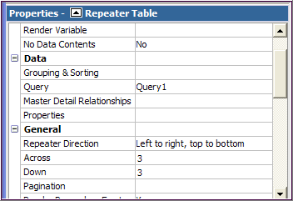

- Run the report (Term = 2008 Fall Semester, Run Date ID = Official).

You should see a Cognos Viewer window with 9 frames per page. Click Page down to see the remaining pages.
- Close the Cognos Viewer window.
- On the Report Studio File menu, click Save As.
- In the Save As Name box, type your initials Repeater List. Click Save.

End of Exercise #6

Crosstab Reports
A crosstab report shows information in summary form. The report still has rows and columns, but the intersection of the rows and columns shows a summary of quantitative information. You can create crosstab reports in two ways:

- Create a new Report Studio report, selecting Crosstab from the New box.
- Open an existing List report and use the Pivot button to change it into a crosstab.

Crosstab reports can contain nested data to make it easy to compare or increase the information you see.

In the following exercise, you will create a new crosstab report.

Exercise 7—Create a New Crosstab Report

- On the Report Studio toolbar, click the New button to create a new report. If you are asked if you want to save the previous report, click Yes.
- In the New box, select Crosstab 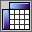 and click OK. You will see a window work area like the one below:

- On the Source tab, expand the UDSIS Training Extract item by clicking on the plus sign.
Note: You must drag each field to the work area separately in a Crosstab report.
- Click Student_Type and drag it to the Columns section of the work area.
- When you see the Columns area flash black, release the mouse button.
- Click the title of the Student_Type column and click the Sort button. Select Sort Ascending.
- Click College and drag it to the Rows section of the work area.
- When you see the Rows area flash black, release the mouse button.
- Click the title of the College row and click the Sort button. Select Sort Ascending.
- Click COUNT-FIELD (in the Statistics folder) and drag it to the Measures section of the work area.
- When you see the Measures area flash black, release the mouse button.
Your work area should look like the one below:

Note: If you want to create an Excel-like crosstab, you must be sure that the data field you want Report Studio to recognize as a fact (quantitative data) is dropped into the report as a measure. Otherwise, it will not be treated correctly.

- Run the report (Term = 2008 Fall Semester, Run Date ID = Official). You will see a report like the one below.

The intersection of the rows and columns shows the number of types of students in each college.

Close the Cognos Viewer window.

►Suppose you want your crosstab report to show the academic load for each type of student listed by department in each college. You can nest information by dragging additional items into the report rows or columns.
- In the Program folder, click ACADEMIC_ORG and drag it to the right of College in the Rows section of the work area.
  - When you see the bold black bar, release the mouse button.
  - The work area should look this afterward:

- Click the title of the ACADEMIC_ORG row and click the Sort button. Select Sort Ascending.

- Click UD_ACADEMIC_LOAD (under UDSIS Training Extract)
  - Drag it under the Student_Type item in the Columns section of the work area.
  - When you see the bold black bar, release the mouse button.

  - The work area should look this afterward:

- Click the title of the UD_ACADEMIC_LOAD item and click the Sort button. Select Sort Ascending from the Sort menu.
- Run the report (Term = 2008 Fall Semester, Run Date ID = Official). Your Cognos Viewer window should now look like the one below.

Click Page down to see the rest of the information.
Close the Cognos Viewer window.

►At times, a crosstab report may be easier to read if you swap the rows and columns.

- In the Report Studio window, click the Student_Type column title.
- On the toolbar, click the Swap Rows and Columns button.

- The work area should look like this one:

- Run the report (Term = 2008 Fall Semester, Run Date ID = Official) and compare it with the one shown in step 17 above.

This report is extremely wide, note the scroll bar at the bottom.
- Close the Cognos Viewer window

- On the Report Studio window File menu, click Save As.
- In the Save As Name box, type your initials Nested Crosstab. Click Save.

Note: You will not perform all these steps for every crosstab report. The steps you select depend upon your individual needs.

End of Exercise #7

In the previous exercise, you created a new crosstab report using a Report Studio template.
You can also create a crosstab report using an existing list report. There are two ways to do this:
- Open an existing report from within Report Studio, or
- From Cognos Connection, click the Public Folders tab.
  - Select UDSIS Training Extract, and search for your report.
  - Once you have located the report you want to edit, click the More… link at the far right of the line it is on.
  - Select Edit with Report Studio.

In the following exercise, you will create a crosstab report based on the Grouped Campus report you created earlier. You will open the report in Report Studio and make a few changes before you create the crosstab.

Exercise 8—Create a Crosstab Report from an Existing Report

- In Report Studio, click Open in the tool bar. If you are asked if you want to save the previous report, click Yes.
- In the Open dialog box, find the report named your initials Grouped Campus. Click the report to select it and click Open. (Hint: you may need to change Public Folders to My Folders with the drop-down.)
- To add a measure to the report (every crosstab must have at least one measure), expand the Statistics item and double-click COUNT_FIELD.
A COUNT_FIELD column appears after the last report column.

Suppose that to make the report more succinct, you decide to remove the MAJOR1 column before you create the crosstab. You can remove Report Studio information either permanently by clicking the Delete button or temporarily by clicking the Cut button.
Note about Delete vs. Cut:

Delete removes the data item from the report layout and the query. If you delete a data item, it will no longer appear on the Data Items tab. To add it back, go to the Source tab.

Cut removes the data item from the report layout but retains it in the query that Cognos uses to retrieve data from the source. To add it back, go to the Data Items tab.

- Click the title of the MAJOR1 column to select it then click the Cut button on the Tool Bar.
(Notice the MAJOR1 column is removed. However, it still remains available on the Data Items tab of the Insertable Objects pane.)
- Click the Data Items tab on the Insertable Objects pane to see the structure of the query Report Studio is building. Note that the MAJOR1 item is still in the query.
If you wanted to add it back into your report, you would drag it to the position you wanted it to occupy.

- Click the title of the CAMPUS column (this is the item you want to appear in the columns section of your crosstab).

- On the tool bar, click the Pivot List to Crosstab button then run the report.

- The work area should look like this:

- Run the report (Term = 2008 Fall Semester, Run Date ID = Official)

Your Cognos Viewer report will look like the one below:
- Close the Cognos Viewer window.

- On the Report Studio window File menu, click Save As.
- In the Save As Name box, type your initials List to Crosstab. Click Save.

End of Exercise #8

Charts

Charts allow you to present your information graphically. Report Studio offers 12 types of charts with multiple configurations for each type. To see the chart types, you can open the New report box in Report Studio and select Chart.

Besides being able to create many different types of charts based on Report Studio templates, you can alter the appearance of a chart by changing its properties to include background images, and foreground and background colors. You can also change chart labels and titles.
In the following exercise, you will view the types of charts available in Report Studio and learn how to choose the one most suited to your purposes.

Exercise 9—View the Types of Report Studio Charts

- On the Report Studio toolbar, click the New button to create a new report.

- In the New box, select Chart and click OK.

- You will see a window like the one below:
- Click some of the chart types in the Chart group pane. For each item you select, you will see all the configurations available for that particular chart type in the Chart type pane.
- Click some of the chart configurations in the Chart type pane.
When you select a configuration, you will see the type of chart configuration immediately under Chart type. At the same time, you will see an explanation of how the chart will appear and what it is used for.

End of Exercise #9

Create a Chart
When you create a chart in Report Studio, you add data to three drop zones. Drag items into the zones where you want them to appear. The zones are:

- Default Measure: The numbers that will be plotted on the Y axis (vertical).
(Examples: counts, dollar amounts)
- Category: The values that appear on the X axis (horizontal) against which each data series is plotted. (UDSIS: academic career, major, and UD Financials: Purposes, Account categories)
- Series: A group of related data points. The data series appear in the chart’s legend, with each series having a different color or pattern.
(Examples: terms, fiscal years or accounting periods)

In the following exercise, you will create a column chart and change some of its properties. The chart will show enrollment by academic level for terms 2078 and 2088.

Exercise 10—Create a Column Chart

- In the Insert Chart box that you opened in the previous exercise, click the icon for the Column chart and click OK.

- You will see a work area like the one below:
Note the three drop zones and where the data will appear on the chart.

Add fields to the work area:
- On the Source tab, expand the UDSIS Training Extract item by clicking the plus sign.
- In the Statistics folder, click COUNT_FIELD and drag the selection to the Default Measure drop zone of the chart.
- Click ACADEMIC_CAREER and drag the selection to the Category drop zone of the chart.
- Click the ACADEMIC_CAREER item and click the Sort button. Select Sort Ascending.
- Click ACAD_LEVEL and drag the selection below ACADEMIC_CAREER in the Category drop zone of the chart.
When you see a bold, black bar, release the mouse button.
- Click the ACAD_LEVEL item and click the Sort button. Select Sort Ascending.
- Click ACADEMIC_TERM and drag the selection to the Series drop zone of the chart.

Your work area should look like the one below:

- To give the report a title, double-click just above the report columns on the words that say Double click to edit text. In the text box that appears, type: Enrollment by Academic Level and click OK.
Note: This is the way to add a title to any Report Studio report.

- Run the report to see the chart you have created.

- In the Prompt box, click 2007 Fall Semester and 2008 Fall Semester, click the Reprompt button at the top. Click on the Run Date ID = Official, then click OK.

Note that Report Studio has added labels for the axes and legend as well as the date, page number, and time at the bottom of the page:

- Close the Cognos Viewer window.
►You can change chart labels to make them more meaningful. To do this:
- In the Report Studio window, click the Measure drop zone (it now reads COUNT_FIELD). Note the properties you can apply to the COUNT_FIELD item.

- In the Properties pane, click the Custom Label property then from the pull-down menu, select Show. Notice that there is a new area for editing text in the Default Measure box.
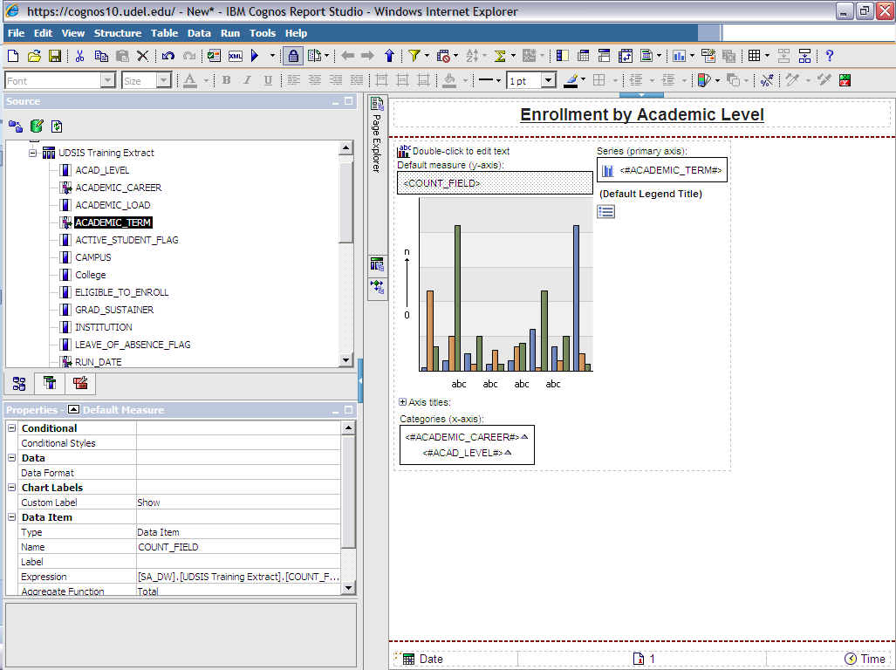

- Double-click where indicated to edit the text.
- In the Text box, type Number of students and click OK.

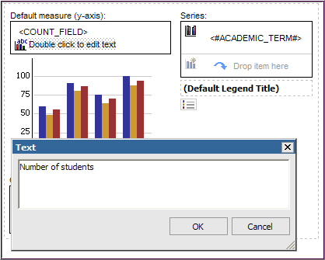

- Run the report again, (click 2007 Fall Semester and 2008 Fall Semester, Run Date ID = Official) to see the title change on the Y axis.
- On the File menu, click Save As.
- In the Save As Name box, type your initials Enrollment Chart. Click Save.

►If you decide another chart type would better represent your data, you can change types from within the chart window.
- Click the Series icon on the chart to highlight it.
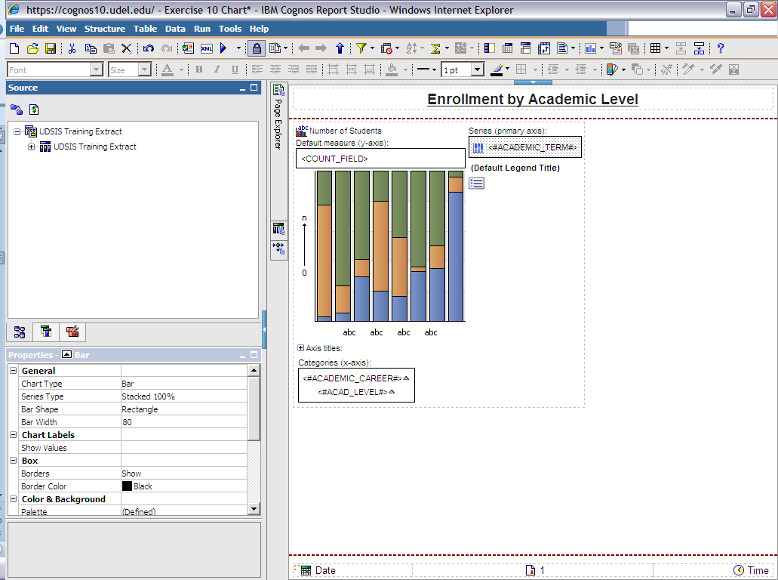

- In the Properties pane, under General, click Series Type.
- From the pull-down menu, select Stacked 100%.
- Run the report (click 2007 Fall Semester and 2008 Fall Semester, Run Date ID = Official) to see how the chart looks now. (Compare it to the previous one.)

Close the Cognos Viewer window.

Save the report if you want to keep these changes.

End of Exercise #10
Manipulate Data in a Report

You can manipulate Report Studio data in many ways to produce a report that shows only the information relevant to your audience’s needs. Some of the changes you can make are:

- Add a filter to produce a subset of results.
- Sort and group data to produce custom reports.
- Format data to change the appearance of numbers, currency, dates, and times.
- Perform calculations using your data.

Filters

To produce a report that shows a subset of your data, you can add a filter to a report item.

Suppose you produce a report that shows the number of students in graduate-level programs at the University. You might want your results to show only the number of Masters-level students in each major, excluding all other data. The following exercise will show you how to create this report.
Exercise 11—Add a Filter

- On the Report Studio toolbar, click the New button to create a new report. If you are asked if you want to save the previous report, click No.

- In the New box, select List and click OK.
- On the Source tab, expand the UDSIS Training item by clicking the plus sign

- Add the following fields to your report:
- CAMPUS
- Student_Type
- MAJOR1 (in the Program folder)
- COUNT_FIELD (in the Statistics folder)
- Click the title of the CAMPUS column and click the Sort button. Select Sort Ascending.
- Click the title of the Student_Type column and click the Sort button. Select Sort Ascending.
- Group two fields to remove duplicate values:
  - Click the title of the CAMPUS item,
  - Hold down the SHIFT key and click the title of Student_Type.
  - Click the Group/Ungroup button on the toolbar.
Your list will look like the one below:

- Run the report (Term = 2008 Fall Semester, Run Date ID = Official) to view.

- Close the Cognos Viewer window.

- Click the title of COUNT_FIELD then click the Filters button on the toolbar and then click Edit Filters.
3rd
2nd
1st

- A new window will open. Click the Add button.

- A Create Filter box will open. Click the Advanced radio button, and then click OK.

- You will see a Detail Filter Expression window like the one below:
- In the Available Components pane, expand the UDSIS Training Extract tab by clicking the plus sign and double-click ACADEMIC_CAREER.
[SA_DW].[UDSIS Training Extract].[ACADEMIC_CAREER] will now appear in the Expression Definition pane.
- Click in the Expression Definition pane just after [ACADEMIC_CAREER] and type =’GRAD’ your expression should look like this:

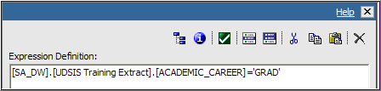

- Click the Validate button to ensure that there are no mistakes in the expression. When the Prompt window appears, Term = 2008 Fall Semester, Run Date ID = Official

- You will see the validation results in the Information pane.
  - If you see No Errors, click OK.
  - If you get an error, correct your expression.

- This returns you to the Filters window. Click OK again.
- Run the report (Term = 2008 Fall Semester, Run Date ID = Official) to see the effect of the filter you have added. The report now shows all graduate programs at the University with the Students enrolled in them. Close the Cognos Viewer window.

►Suppose you want to see only programs with Masters-level students in them. You can add more filters to your report to do this.
- Click the title of the COUNT_FIELD item then click the Filters button on the toolbar and then click Edit Filters.
- In the Filters window, click the Add button. A Create Filter box will open. Click the Advanced radio button, and then click OK

- In the Available Components pane, expand the UDSIS Training Extract tab by clicking the plus sign and double-click ACAD_LEVEL.
[SA_DW].[UDSIS Training Extract].[ACAD_LEVEL] will now appear in the Expression Definition pane.
- Click in the Expression Definition pane just after [ACAD_LEVEL] and type =’M’
- Click the Validate button to ensure that there are no mistakes in the expression.

- If you get “No Errors,” click OK. This returns you to the Filters window.

- Click the Add button. A Create Filter box will open. Click the Advanced radio button, and then click OK.
- In the Available Components pane, expand the UDSIS Training Extract tab by clicking the plus sign and double-click LEAVE_OF_ABSENCE_FLAG.
[SA_DW].[UDSIS Training Extract].[LEAVE_OF_ABSENCE_FLAG] will now appear in the Expression Definition pane.
- Now we’ll add another expression with the operator ‘and’:
  - Click just after [LEAVE_OF_ABSENCE_FLAG] and type ='N'
  - Move one space and type: and
  - Move one space and, under the UDSIS Training item, double-click ACTIVE_STUDENT_FLAG to add this field
  - Click just after [ACTIVE_STUDENT_FLAG] and type ='Y'

Your expression should look like the one below:

- Click the Validate button to ensure that there are no mistakes in the expression. Then click OK. This returns you to the Filters window. Click OK again.
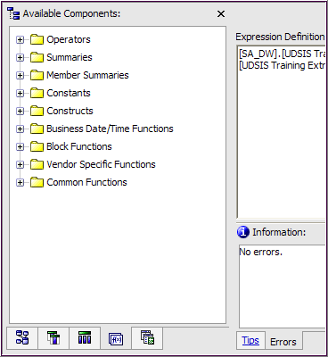

Note: Alternatively, you can use the Functions tab to build your expressions. It contains numerous operators and specialized functions.

Operators, such as “and” can be found in the Operators folder.

- Run the report (Term = 2008 Fall Semester, Run Date ID = Official). You will see a Cognos Viewer window like the one below. Page down in the window to see all of the data.

The report now reflects the new filter; only Masters-level students for each major are included in the report. Close the Cognos Viewer window.

Note: To Edit a filter, click the Report Studio column that has been filtered then click the Filter icon. In the Filters box, click the filter and then click the Edit icon.

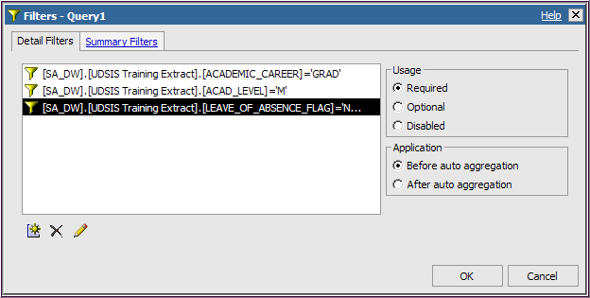

- On the Report Studio File menu, click Save As.
- In the Save As Name box, type your initials Add a Filter. Click Save.

End of Exercise #11

Disable Filters

After you create a report with filters, it is possible to customize it by disabling filters you've added. This allows you to keep all the filters and to use them selectively. In the following exercise, you will disable some of the filters you created in the your initials Add a Filter report.

Exercise 12—Disable Filters

This exercise continues with the report (your initials Add a Filter) from Exercise 11. If needed, open the file with the Open button; it should be in My Folders.

- Click the Filters button on the toolbar and click Edit Filters. You will see a
window that looks like the one below:

- Highlight the second filter and in the Usage pane, click Disabled.
- Highlight the third filter and in the Usage pane, click Disabled. Click OK.
- Run the report to see the effect of disabling the filters. The report now shows all graduate programs at the University with students enrolled in them. Close the Cognos Viewer.

End of Exercise #12

Filter on Details and Summaries

You can filter reports in several ways. In the following exercise, you will create a report, total the data, and filter first on detail data and then on the summary data.
Exercise 13—Filter on Details

- On the Report Studio toolbar, click the New button to create a new report. If you are asked if you want to save the previous report, click No.
- In the New box, select List and click OK.
- On the Source tab, expand the UDSIS Training item by clicking the plus sign and add the following fields to the work area:
  - CAMPUS
  - Student_Type
  - ACADEMIC_ORG_LDESCR (in the Descriptions folder)
  - COUNT_FIELD (in the Statistics folder)
- Add a line for the total of all students:
  - Click the title of the COUNT_FIELD item
  - On the toolbar, click the Aggregate button’s down-arrow
  - Click Total.
- Click the title of the ACADEMIC_ORG_LDESCR column and click the Sort button. Select Sort Ascending.
- To get rid of duplicate values:
  - Click the title of the CAMPUS item.
  - Hold down the SHIFT key and click the titles of the Student_Type and ACADEMIC_ORG_LDESCR items.
  - Click the Group/Ungroup button on the toolbar to group the items.

Your work area should look like the one below:

- Run the report (Term = 2008 Fall Semester, Run Date ID = Official) and notice the data in the aggregate report. The total of all students appears at the bottom of the report. Page down to see all of the data (below are the first and last pages of the report):
- Close the Cognos Viewer window.

►Suppose you want your report to show only the number of undergraduates for each academic organization on the Newark campus. You can create filters to show only this data.

- Click the title of the COUNT_FIELD column and, on the toolbar, click the Filters button and then click Edit Filters.

- In the Filters window, click the Add button. A Create Filter box will open. Click the Advanced radio button, and then click OK.
- Under the Available Components pane, click the Data Items icon and double-click CAMPUS.
[CAMPUS] will now appear in the Expression Definition pane.

- In the Expression Definition pane, click just after [CAMPUS] and type ='NEWRK'

HINT: If you don't know the values for CAMPUS (or any other data item), use the Select Value button:
- After you double-click CAMPUS, type =
- Click the Select Value button (next to the Validate button)
- You will see the Select Value box.
- Double-click a value to add it to the expression definition.
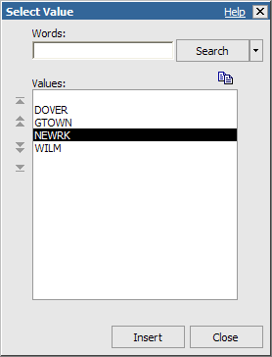

- Click the Validate button to ensure that there are no mistakes in the expression; check for errors in the Information pane. Then click OK. This returns you to the Filters window.

- To add a filter for Student_Type, click the Add button. A Create Filter box will open. Click the Advanced radio button, and then click OK.
- Under the Available Components pane, click the Data Items icon and double-click Student_Type.
[Student_Type] will now appear in the Expression Definition pane.
Note: When you create a filter, select items that are already in your report from the Data Items tab. Select items that are not in your report from the Source tab.

- In the Expression Definition pane, click just after [Student_Type] and type ='UGRD' (Or use the Select Value button.) Your expression should look like this one:
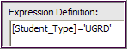

- Click the Validate button to ensure that there are no mistakes in the expression; check for errors in the Information pane. Then click OK. This returns you to the Filters window.
- Click the Add button. A Create Filter box will open. Click the Advanced radio button, and then click OK.
- On the Source tab, expand the UDSIS Training item by clicking the plus sign and double-click LEAVE_OF_ABSENCE_FLAG.

- Add another field to the expression:
  - Click just after [LEAVE_OF_ABSENCE_FLAG] and type ='N'.
  - Move one space and type and.
  - Move one space and, under the UDSIS Training item, double-click ACTIVE_STUDENT_FLAG.
  - Click just after [ACTIVE_STUDENT_FLAG] and type ='Y'.
The complete expression should look like the following:
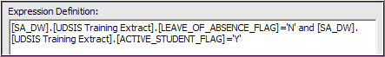

- Click the Validate button to ensure that there are no mistakes in the expression. Then click OK. This returns you to the Filters window. Click OK again.

Note: Values in expressions must be in single quotes. If you accidentally use double quotes, you will get an ugly error in the Information pane when validating.

Examples: ‘N’ and ‘NEWRK’ are correctly written with single quotes.

- Run the report. You will see a Cognos Viewer window like the one below that now shows only numbers for undergraduates on the Newark campus. Page down in the window to see all of the data.
This shows the first and last pages of the report.

- Close the Cognos Viewer window.

- In the Report Studio window, click the Filters button and then click Edit Filters. Click on one of the filters you created.

Note that in the Application box, Before auto aggregation is selected:
This means that you filtered on the details in the report—the data in the rows— before the aggregation was applied. Cancel the Filters window.

[The next exercise will, in contrast, show the effect of a filter with After auto aggregation selected.]
- On the Report Studio File menu, click Save As.
- In the Save As Name box, type your initials Filtered Details. Click Save.
End of Exercise #13
Note: You will apply only the filters you need in your reports. The varying types of filters used in this exercise illustrate the possibilities for applying filters and demonstrate that multiple filters can be used in a single report.

In the following exercise, you will add a filter to the report you just created to produce a summary filter.

Exercise 14—Create a Summary Filter

- On the Report Studio toolbar, click the New button to create a new report. If you are asked if you want to save the previous report, click No.

- In the New box, select List and click OK.
- On the Source tab, expand the UDSIS Training item by clicking the plus sign and add the following fields to the work area:
  - CAMPUS
  - Student_Type
  - MAJOR1 (in the Program folder)
  - ACADEMIC_ORG_LDESCR (in the Descriptions folder)
  - COUNT_FIELD (in the Statistics folder)
- Next, you'll add one more item to the report—a calculation that you define yourself.

- In the Insertable Objects pane, click the Toolbox tab icon and drag Query Calculation to the report. Drop it after COUNT_FIELD when you see the black bar.

- In the Create Calculation box, type Rank

- Click OK.

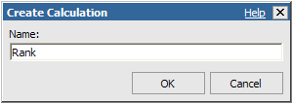
- This brings up the Data Item Expression box so that you can define the calculation.

- In the Expression Definition pane, type: rank()

- On the Available Components Data Items tab, click [COUNT_FIELD] and drag it within the parentheses.

- Click the Validate button to ensure that there are no mistakes in the expression and click OK.
- Back in the work area, you’ll add a summary for the total of all students:
- Click the COUNT_FIELD column
- On the toolbar, click the Aggregate button’s down-arrow.
- Click Total.
- To get rid of duplicate values:
  - Click the title of the CAMPUS item.
  - Hold down the SHIFT key and click the title of the Student_Type item

- Click the Group/Ungroup button on the toolbar to group the items.
- Click the title of the Rank item and click the Sort button. Select Sort Ascending.
Your work area should look like this one:

- Run the report (Term = 2008 Fall Semester, Run Date ID = Official) to see the kinds of information it produces. Close the Cognos Viewer window.

►Suppose you want your report to show a summary of the 20 most popular undergraduate academic programs on the Newark campus. You can create filters to show this information.
- Click the title of the COUNT_FIELD column and, on the toolbar, click the Filters button and then click Edit Filters.
- Click the Add button. Click the Advanced radio button and then click OK.
- Under the Available Components pane:
  - Click the Data Items tab
  - Double-click CAMPUS.
- In the Expression Definition pane, click just after [CAMPUS] and type ='NEWRK' or use the Select Value button (See Hint on page 46) to select a value. Your Expression should look like this one:

- Click the Validate button to ensure that there are no mistakes in the expression. Then click OK. This returns you to the Filters window.
- Click the Add button. Click the Advanced radio button and then click OK.
- Under the Available Components pane, click the Data Items icon and double-click Student_Type.
- In the Expression Definition pane, click just after [Student_Type] and type ='UGRD'

- Click the Validate button to ensure that there are no mistakes in the expression. Then click OK. This returns you to the Filters window.
- Click the Add button. Click the Advanced radio button and then click OK.
- Under the Available Components pane, click the Data Items icon and double-click Rank.

- In the Expression Definition pane, click just after [Rank] and type <=20.

- Click the Validate button to ensure that there are no mistakes in the expression. Click OK. This returns you to the Filters window.
- With [Rank]=<20 highlighted in the Application box of the Detail Filters window pane:
  - Click After auto aggregation
  - Click OK

- Back at the work area, you’ll add another filter to include only active students in the report.
  - Click the title of the COUNT_FIELD column
  - On the toolbar, click the Filters button and then click Edit Filters.
- Click the Add button. Click the Advanced radio button and then click OK.
- On the Source tab, expand the UDSIS Training item by clicking the plus sign.
  - Double-click LEAVE_OF_ABSENCE_FLAG.
  - Click just after [LEAVE_OF_ABSENCE_FLAG] and type ='N'.
  - Move one space and type: and.
  - Move one space and, under the UDSIS Training item, double-click ACTIVE_STUDENT_FLAG.
  - Click just after [ACTIVE_STUDENT_FLAG] and type ='Y'.
Your expression should look like the following:

- Click the Validate button to ensure that there are no mistakes in the expression. Click OK. This returns you to the Filters window. Click OK again.
- Run the report (Term = 2008 Fall Semester, Run Date ID = Official). The filter for Rank is being applied to the data after the aggregation. Close the Cognos Viewer window.

- In the Save As Name box, type: your initials Summary Filter. Click Save.
End of Exercise #14

Filter Crosstabs

You can filter crosstab reports using all the methods we have discussed for filtering list reports. In the following exercise, you will create a crosstab report and filter it in several ways to see subsets of the data you are using.

Exercise 15—Filter a Crosstab Report

- On the Report Studio window toolbar, click the New button to create a new report.
- In the New box, select Crosstab and click OK.
- On the Source tab, expand the UDSIS Training Extract item by clicking on the plus sign.
- Click Student_Type and drag the selection to the Columns section of the work area. When you see the Columns area flash black, release the mouse button.
- Click the title of the Student_Type column and click the Sort button. Select Sort Ascending from the Sort menu.
- Click College and drag the selection to the Rows section of the work area. When you see the Rows area flash black, release the mouse button.
- Click the title of the College row and click the Sort button. Select Sort Ascending from the Sort menu.
- Click COUNT-FIELD (in the Statistics folder) and drag the selection to the Measures section of the work area. When you see the Measures area flash black, release the mouse button.
- Click ACADEMIC_ORG_LDESCR (in the Descriptions folder) and drag the selection to the right of College in the Rows section of the work area. When you see the bold black bar, release the mouse button.
- Click the title of the ACADEMIC_ORG_LDESCR row and click the Sort button. Select Sort Ascending from the Sort menu.
- Under the UDSIS Training Extract item, click UD_ACADEMIC_LOAD and drag the selection under the Student_Type item in the Columns section of the work area. When you see the bold black bar, release the mouse button.
- Click the title of the UD_ACADEMIC_LOAD item and click the Sort button. Select Sort Ascending from the Sort menu. Your work area should look like the one below:

- Run the report (Term = 2008 Fall Semester, Run Date ID = Official) to see the data available to you. Close the Cognos Viewer window.

►Suppose you want to filter your report to see only data for students in specific colleges. To do this:
- Click the title of the COUNT_FIELD column. Click the Filters button on the toolbar and click Edit Filters.
- In the Filters window, click the Add button, click the Advanced radio button and then click OK. (See Hint below):
[COLLEGE] in (‘AS’,'AG',’BE','EG','HN','HP')

Note: Each item within the parentheses must be enclosed in single quotes, and items are separated by commas. Also, there can be no spaces between items in parentheses.

HINT: If you don't know the values for College (or any other data item), use the Select Multiple Values button:
- After you double-click College, type in
- Click the Select Multiple Values button (near the Validate button).
- You may be prompted to enter a term (Term = 2008 Fall Semester and Run ID = Official).
- You will see the Select Multiple Values box.
- Click the Green Arrow or Double-click each Value to add it to the Selected Values box.
- When you are done adding values, click the Insert button to add them to your expression.

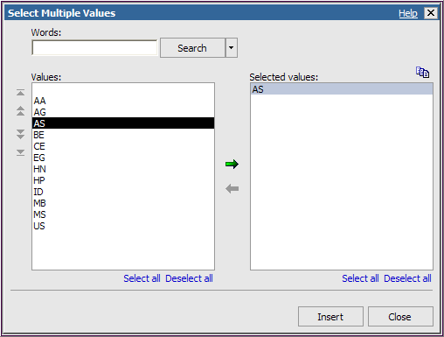

- Click the Validate button then click OK. This returns you to the Filters window.

- Click OK again and then run the report.

- Run the report (Term = 2008 Fall Semester, Run Date ID = Official) to see the data available to you. Close the Cognos Viewer window.
► Suppose you want to show data for only full and part-time students. You can add a filter to do this:
- Click the title of the COUNT_FIELD column. Click the Filters button on the toolbar and click Edit Filters. In the Filters window, click the Add button, click the Advanced radio button and then click OK. Create the following filter:
[UD_ACADEMIC_LOAD]<>'N' (This function will only retrieve values that are not equal to "N".)
- Click the Validate button then click OK. This returns you to the Filters window. Click OK.

- Run the report (Term = 2008 Fall Semester, Run Date ID = Official) to see the data available to you. Close the Cognos Viewer window.

► Suppose you want to refine your report even more to show only full-time students in programs with fewer than 50 students. You can add a filter to do this:

- Click the title of the COUNT_FIELD column. Click the Filters button on the toolbar and click Edit Filters.

- In the Filters window, click the Add button, click the Advanced radio button, and then click OK. Create the following filter:
[UD_ACADEMIC_LOAD]=’F’ and [COUNT_FIELD]<50

- Click the Validate button then click OK. This returns you to the Filters window.

- In the Filters window, click After auto aggregation and click OK.
- Run the report (Term = 2008 Fall Semester, Run Date ID = Official) to see the data available to you. Close the Cognos Viewer window.

- In the Save As Name box, type your initials Crosstab Filter. Click Save.

Recap about the filters used in this report:

- The first two were run before auto aggregation, and the third was run after auto aggregation.
- In the third filter, the expression used the “and” operator to combine the filters to create one filter.
- You can include multiple filters (both before and after aggregation) in any report.

End of Exercise #15

Prompts
You can give people who will be running your report the ability to customize the information by adding prompts. Prompts have 3 elements:

- Parameters—the choices you give people
- Prompt controls—the prompt page where people make their choices. In Report Studio, people do this in the Cognos Viewer window.
- Parameter values—the results of the choices people make.

In Report Studio, you can build prompts in a couple of ways.
- The simplest way is to have Report Studio build the prompt for you. Anytime you add a particular parameter to a Report Studio filter, it will prompt the user for information.
- Report Studio also offers a Build Prompt Page tool that creates a default prompt page based on the report items you select. You can customize this report or create your own custom prompt pages.
In the following exercise, you will create a report that shows the number of full-time equivalent students for a term. And you will then add a prompt that allows users to select specific a Campus (the first method).
Exercise 16—Add a Prompt

- On the Report Studio window toolbar, click the New button to create a new report.
- In the New box, select List and click OK.

- On the Source tab, expand the UDSIS Training item; add the following fields to the work area:
  - CAMPUS
  - Student_Type
  - UD_ACADEMIC_LOAD
  - COUNT_FIELD (in the Statistics folder)

Next, you will add a calculation to your report to find out the number of full-time equivalent majors.

- Use the Query Explorer bar to create two new data items. Then you will create a data item named "LOAD" which will narrow the Student_Type choices to full or part-time
In the center of the Report Studio window, move the mouse pointer over the Query Explorer icon to open it, and click Query1.

- In the Insertable Objects pane, click the Toolbox tab.

- Drag Data Item to Data Items pane.
- This brings up the Data Item Expression box.

- This will launch the Data Item Expression window. In the Expression Definition pane, drag items from the Data Items tab and type other elements to create the following definition:
if ([UD_ACADEMIC_LOAD]='F') then ([UD_ACADEMIC_LOAD]) else ('P')
Note: Parentheses are very important in” if-then-else” statements. Be careful not to exclude them or put them in the wrong spot.

- Click the Validate button. If you get “No errors,” click OK.

- With Data Item 1 highlighted in the Data Items pane:

- Click Name in the Properties pane
- Type LOAD in the box (replacing the words “Data Item 1”)
- Press the ENTER key.
Note: The LOAD item you added is part of your query but will not be an item in the report itself.
Next, you will add a data item for full-time equivalent majors that you will name FTE.

- In the Insertable Objects pane (Hint: see step 5 above):
- Click the Toolbox tab.
- Drag Data Item to Data Items pane.
- This brings up the Data Item Expression box.

- In the Expression Definition pane, drag items from the Data Items tab and type other statements to create the following definition:
if ([LOAD]='F') then ([COUNT_FIELD]) else ([COUNT_FIELD]/3)
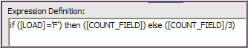
This expression will count each full-time (F) student as 1 FTE and all other students (part-time) as 1/3 of an FTE.

- Click the Validate button. If you get “No errors,” click OK.

- With Data Item 1 highlighted in the Data Items pane:
- Click Name in the Properties pane.
- Type FTE in the box (replacing the words “Data Item 1”) .
- Press the ENTER key.
- In the center of the Report Studio window, move the mouse pointer over the Page Explorer bar to open it. Click Page 1 to return to your report work area.
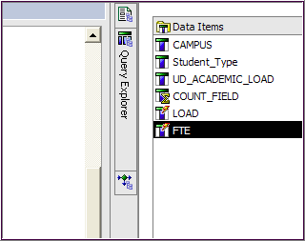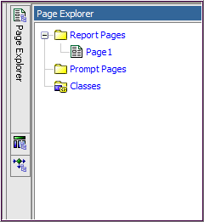

- In Insertable Objects, click the Data Items tab
- Double-click FTE to add it to your report

- Add a summary for the totals of all students and of FTEs:
  - Select the COUNT_FIELD and FTE columns (Click with the SHIFT key to select both).
  - On the toolbar, click the Aggregate button’s down-arrow.
  - Click Total.

Your work area should look like this one:

The following three steps (17 through 19) simply provide some order to your report by sorting and grouping (to remove duplicate values).
- Click the title of the CAMPUS column and click the Sort button. Select Sort Ascending.
- Click the title of the Student_Type column and click the Sort button. Select Sort Ascending.
- Click the titles of the CAMPUS and Student_Type columns then click the Group/Ungroup button to remove duplicate values. Your work area should look like this one:
You will also create some filters so that the report will show the data you want.

- Click the title of the COUNT_FIELD column. Click the Filters button on the toolbar and click Edit Filters.
- In the Filters window, click the Add button. Click the Advanced radio button, and then click OK.
- Create a prompt that requires the viewer of the report to select a campus from a drop-down list.
- Under the Available Components pane, click the Data Items icon.
- Double-click CAMPUS.
- [CAMPUS] will now appear in the Expression Definition pane.
- Click just after [CAMPUS] and type: =?Enter Campus?
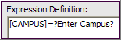

- Click the Validate button

- Follow the prompts to ensure that there are “No errors” in the expression.

Click OK. This returns you to the Filters window.
- In the Filters window, click the Add button. Click the Advanced radio button, and then click OK. Use your knowledge of filters to create the following filter for your report.
[SA_DW].[UDSIS Training Extract].[LEAVE_OF_ABSENCE_FLAG]='N' and [SA_DW].[UDSIS Training Extract].[ACTIVE_STUDENT_FLAG]='Y'
- Click Add button. Click the Advanced radio button, and then click OK. Create this filter:
[UD_ACADMEIC_LOAD]<>'N'

- Click the Validate button. If you get “No errors,” click OK and OK again.

- Change the format of the FTE item so that it shows only one decimal point:
  - Click the title of the FTE column
  - From the Data menu, select Default Data Formats

  - In the Default Data Formats box, click Number and click No. of Decimal Places

  - From the drop-down menu, select 1 and click OK.

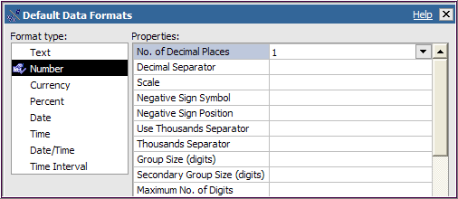

- Run the report.

- Choose an Academic Term/Run ID and type a Campus from the Prompt page. (Campus = NEWRK, Term = 2008 Fall Semester, Run ID = Official.)

- Your report should look similar to the one below.
Notice the COUNT_FIELD is divided by 3 to calculate the FTE for part-time students (P).

(The expression in the data item created this calculation.)
- Close the Cognos Viewer window.

- On the Report Studio File menu, click Save As.
- In the Save As Name box, type your initials Add a Prompt. Click Save.

End of Exercise #16

The previous exercise demonstrated the simplest form of a Report Studio prompt—adding a filter with a parameter. This will automatically generate a prompt page in the Cognos Viewer.

In the next exercise, you will use the “Build Prompt Page” tool to create a more complex prompt. Once again, Report Studio will build the prompt for you. The report will show the total number of students on specific campuses.
Exercise 17—Use the “Build Prompt Page” tool

- On the Report Studio toolbar, click the New button to create a new report.
- In the New box, select List and click OK.
- On the Source tab, expand the UDSIS Training item and add the following fields to the work area:
  - CAMPUS
  - Student_Type
  - COUNT_FIELD (in the Statistics folder)

- Add a line for the total of all students.
- Click the title of the COUNT_FIELD item.
- On the toolbar, click the Aggregate button’s down-arrow
- Click Total.
- Click the title of the CAMPUS column and click the Sort button. Select Sort Ascending.
- Click the title of the Student_Type column and click the Sort button. Select Sort Ascending.
- Remove duplicate values:
- Click the title of the CAMPUS item, hold down the SHIFT key and click the title of the Student_Type column.
- Click the Group/Ungroup button on the toolbar
Your work area should look like this:

Next you will add filters to the report:
- Click the title of the COUNT_FIELD column. Click the Filters button on the toolbar, then click Edit Filters.
- In the Filters window, click the Add button. Click the Advanced radio button, and then click OK.
- Use your knowledge of creating filters to add the following filters to your report.
[SA_DW].[UDSIS Training Extract].[LEAVE_OF_ABSENCE_FLAG]='N' and [SA_DW].[UDSIS Training Extract].[ACTIVE_STUDENT_FLAG]='Y'
- In the Report Studio window, click the title of the CAMPUS column.
  - Click the Build Prompt Page button. (It’s in the upper right of the toolbar.)
  - Based on the report item you selected, Report Studio builds a prompt page

Yours should look like the one below:

The prompt page includes buttons at the bottom (Cancel, Back, Next, Finish) that your users will click after they select values for their reports.
- Run the report (Campus = NEWRK, Term = 2008 Fall Semester, Run Date ID = Official)

Type NEWRK, click Insert, and then click Finish at the bottom of the page.

The report will show the number of students on the Newark campus for the Fall 2008.
Close the Cognos Viewer window.

(Run the report to see results for other campuses if you like.)

- In the Report Studio window, the Prompt Page should still be showing.
- Click inside the Campus prompt box.
- The Properties pane shows the properties available for customizing the Campus prompt.

- Click the Page Explorer bar. You will see a panel with the structure of your report:
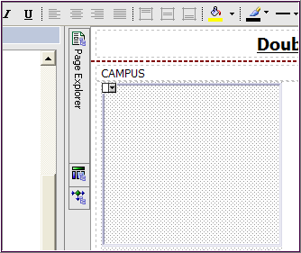 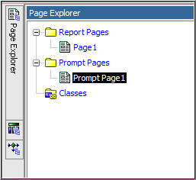
Note that it contains folders for Report Pages and Prompt Pages. You can move from page to page within the Page Explorer.
Page 1 is where you will find the work area with your data items.

- Click Page 1 under Report Pages.

- Click the Filters button on the toolbar. You will see the filter Report Studio has created for the prompt. Click OK to close the Filters window.

- On the Report Studio window File menu, click Save As.

- In the Save As Name box, type your initials Build Prompt Page. Click Save.

End of Exercise #17

Optional Prompts
With an optional prompt, people running your report can choose whether or not to select specific information from prompt boxes you include in a report. The next exercise demonstrates the use of optional prompts.

Exercise 18—Add an Optional Prompt

- On the Report Studio toolbar, click the New button to create a new report.
- In the New box, select List and click OK.
- On the Source tab, expand the UDSIS Training item by clicking the plus sign and add the following fields to the work area:
  - CAMPUS
  - Student_Type
  - MAJOR1 (in the Program folder)
  - COUNT_FIELD (in the Statistics folder)
- Click the title of the CAMPUS column and click the Sort button. Select Sort Ascending.

- Click the title of the Student_Type column and click the Sort button. Select Sort Ascending.
- Click the title of the MAJOR1 column and click the Sort button. Select Sort Ascending.
- Remove duplicate values:
- Click the title of the CAMPUS item
- Hold down the SHIFT key and click the title of the Student_Type column
- Click the Group/Ungroup button on the toolbar.
- Use your knowledge of creating filters to add the following filter to your report. (For detailed instructions go to page 53, steps 31-34.)
[SA_DW].[UDSIS Training Extract].[LEAVE_OF_ABSENCE_FLAG]='N' and [SA_DW].[UDSIS Training Extract].[ACTIVE_STUDENT_FLAG]='Y'
- Run the report (Term = 2008 Fall Semester, Run Date ID = Official) to see the data available. Close the Cognos Viewer window.

►You can add a prompt to see data for only certain student types.
- In the Report Studio window:
- Click the title of the Student_Type column
- On the toolbar, click the Build Prompt Page button.
- Based on the item you select, Report Studio will build a prompt page like this:

- Go back to the work area:
- Click the Page Explorer tab in the center of the Report Studio window.
- Under Report Pages, click Page 1 to open the report page.

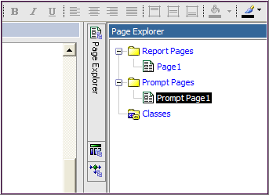
- On the toolbar, click the Filters button, click Edit Filters. Select the filter Report Studio has created for Student_Type.
- In the Filters window Usage box, click Optional, and then click OK.

- Run the report.

- The Cognos Viewer shows a prompt box that looks like the one below:

- Enter the student type or types you want your report to show:

- Type AA in the text box, then click Insert.
- Type CE in the text box, then click Insert.
- Type OFUG in the text box, then click Insert.

- Click Finish to run the report. Enter Term = 2008 Fall Semester, Run Date ID = Official and click OK. Close the Cognos Viewer window.

- On the Report Studio window File menu, click Save As.
- In the Save As Name box, type your initials Optional Prompt. Click Save.

End of Exercise #18

Drill Through Reports

Report Studio allows you to drill through from one report to another report than contains related information. To create a drill through you must have a parent report and a target (child) report. In the target report, you create a filter with a parameter that relates to a column in the parent report. You must create the target report first.

In the next two exercises you will create a target report with detailed data concerning the number of students (full- or part-time) in each college and their majors. In the second (parent) report you will create a report with high level data about headcounts of students in each college. The drill-through you create in the parent report will allow you to see the related information about the number of majors in each college.

Exercise 19—Create a Target Report

- On the Report Studio toolbar, click the New button to create a new report.
- In the New box, select List and click OK.
- On the Source tab, expand the UDSIS Training item by clicking the plus sign and add the following fields to the work area:
  - Academic Program (in the Program folder)
  - MAJOR1 (in the Program folder)
  - Maj1_LDESCR (in the Descriptions folder)
  - ACADEMIC_CAREER_LDESCR (in the Descriptions folder)
  - COUNT_FIELD (in the Statistics folder)

- Click the title of the Academic Program column and click the Group/Ungroup button on the toolbar

- Click the title of the ACADEMIC_ CAREER _LDESCR column and click the Sort button. Select Sort Descending.

- Add a line for the total of students in each major:
- Click the title of the COUNT_FIELD item
- On the toolbar, click the Aggregate button’s down-arrow and select Total

- Give the report a title:
  - Double click the words Double click to edit text
  - In the text box, type: Drill Details and click OK

Your work area should look like this:

Next you will create a filter with a parameter to make this report the target for another report.

- On the toolbar, click the Filters button and click Edit Filters.
- In the Filters window, click the Add button. Click the Advanced radio button and then click OK.
- Click the Available Components tab, and double-click Academic Program

- In the Expression Definition pane, following [College] type: = ?Program?

Your expression should look like the one below.

- Click the Validate button to ensure that there are no mistakes in the expression.
- Prompt page will appear. Type AS in the text box. (Term = 2088 Fall Semester, Run ID = Official).
- Click OK.
- If there are no errors, click OK twice.

- Run the report. Type AS in the text box. (Term = 2008 Fall Semester, Run Date ID = Official) The first page should look like this:

- Close the Cognos Viewer window.

- In the Save As Name box, type: your initials Drill Target. Click Save.

End of Exercise #19

Next, you will create a parent report with a drill through. The parent report will provide a column (College) that will drill through to the target report you just created.

Exercise 20—Create a Parent Report with a Drill Through

- On the Report Studio toolbar, click the New button to create a new report.
- In the New box, select List and click OK.
- On the Source tab, expand the UDSIS Training item by clicking the plus sign and add the following fields to the work area:
- CAMPUS
- Student_Type
- Academic Program
- COUNT_FIELD (in the Statistics folder)

- To get rid of duplicate values:
- Click the title of the CAMPUS item
- Hold down the SHIFT key and click the titles of the Student_Type and Academic Program items.
- Click the Group/Ungroup button on the toolbar to group the items.

- To get totals by campus and all students:
  - Click the title of the COUNT_FIELD column
  - On the toolbar, click the Aggregate button’s down-arrow and select Total

  - The subtotal by Student_Type is not needed, click <Student_Type> in the body of the work area to select it and then click Delete

- Give the report a title:
- Double click the words Double click to edit text
- In the text box, type: Drill Parent and click OK

Your work area should look like this:

Next, you will use the Academic Program column as the drill through to get to the target report.

- Click on the column body of the Academic Program item. It will be highlighted like this:

- On the toolbar, click the Drill-Through Definitions button

- This opens the Drill-Through Definitions window. Click the Add button.

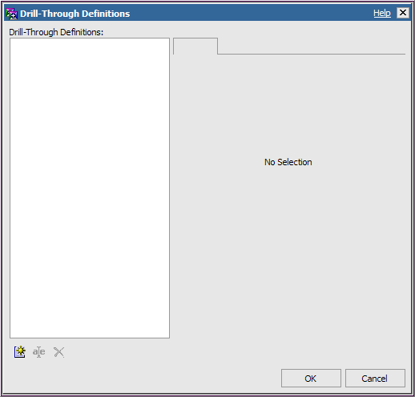

- Click the Ellipsis button next to the Report box.

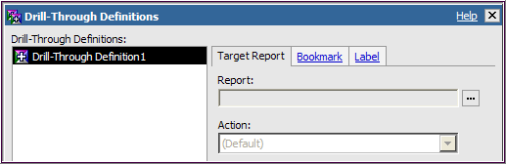

- Navigate to the place you saved the target report and double-click on it. (It should be named: your initials Drill Target)

- Under the Parameters box, click the Edit button

- Report Studio displays the three parameters from the target report; one you created (Program) and the two that were embedded with the package:

- For the Program parameter:
  - Change Method to Pass data item value
  - Change Value to ACADEMIC_PROGRAM

- For the as of parameter:
  - Change Method to Pass parameter value
  - Change Value to as of

- For the term parameter:
  - Change the Method to Pass parameter value
  - Change Value to term

- Your parameters should look like the ones below. Click OK

- Click OK again.

- Your work area should look like this:

- Run the report (Term = 2008 Fall Semester, Run Date ID = Official).

Notice the values in the Academic Program column are all drill through links

Click on one of the links to see what happens.

In this example, click Page Down twice, and then click on AG.

You now can see the related data from the target report.

  - Use your browser’s Back button to go back to the original report to drill through to another college.
  - Close the Cognos Viewer window.
  - Click the Save button, in Name box, type: your initials Drill Parent.

End of Exercise #20
Report Layouts

Report Studio allows you to lay out your own reports using one or any combination of report formats (list, chart, crosstab, etc.) that Cognos offers. You begin with a blank report and build the components based on your reporting requirements. First, you will set up a layout and then add the report components and formats that best suit your data.

The report has three components:

  - Page Header
The page header is optional. It contains information, such as a title or logo, which you want to appear at the top of every page of your report.
  - Page Body
The page body is required. It contains the data derived from your queries.
  - Page Footer
The page footer is optional. It contains information, such as the page number or date, which you want to appear at the bottom of every page of your report.

You will design your report using tables, much as you would in Word or a web page development package. Report Studio offers many table features you are familiar with such as including text, changing text characteristics (color, font, font size, etc.), changing background color, adding images, nesting objects and more.

In the following exercise, you will become familiar with using Report Studio’s table features to create a report that combines several types of report formats.

Exercise 21—Create a Report Layout

- On the Report Studio toolbar, click the New button to create a new report.
- In the New box, select Blank and click OK.

Your blank work area will look like this:

- Add a table to the work area:
- Click the Toolbox tab in the Insertable Objects area.
- Double Click the Table.
- The Insert Table box will appear, accept the defaults as shown below. Click OK.

You will see one row with one table with two boxes (table cells) at the top of the work area.

- Again from the Toolbox tab, scroll down and click List and drag it to the left table cell. The work area will look like this when you are in the right place:

- Also from the Toolbox, drag Chart to the right table cell. You are in the correct place when you see the solid black line.

- The Insert Chart box will appear, you will select: Chart Group = Column, click on the first Column chart, then click OK.

- Staying with the Toolbox, double click the Crosstab icon. A Crosstab will be inserted to the work area below the table.

Remember, work area objects are placed top-to-bottom.

Notice that the table and the crosstab are two separate objects.

►Now you will data to the three components, starting with the List.

- LIST - Click the Source tab, expand the UDSIS Training item and add the following fields to the List report in the work area. (Hint –Click the anywhere on the List first.)
- CAMPUS
- Student_Type
- College
- ACADEMIC_TERM
- COUNT_FIELD (in the Statistics folder)

- To get rid of duplicate values:
  - Click the title of the CAMPUS item.
  - Hold down the SHIFT key and click the titles of the Student_Type and College items.
  - Click the Group/Ungroup button on the toolbar to group the items.
- CHART - Continuing on the Source tab, add these data elements to the Chart:
  - Drag COUNT_FIELD (in the Statistics folder) to the Measures drop zone.
- Drag ACADEMIC_TERM to the Series drop zone.
  - Drag College to the Category drop zone.

- CROSSTAB - Add data items to the Crosstab from the Source tab:
  - Drag COUNT_FIELD (in the Statistics folder) to the Measures section.
- Drag Student_Type to the Rows section.
- Drag ACADEMIC_TERM to the Rows section to the right of Student_Type.
  - Drag College to the Columns section.

- Your work area should look like this:

- Run the report to see the multiple components you have created in one report.

- In the Prompt box, select 2007 Fall Semester and 2008 Fall Semester, Run Date ID = Official, Click OK.

- In Cognos Viewer, the Crosstab is at the end of the report, click to see all three components together on one page.

- The last page of your report should look like this:

- Close the Cognos Viewer window.

►You will now add a page header to your report.
- On the toolbar, click the Headers & Footers button. Select Page Header & Footer.
  - Click the checkbox next to Header.
  - Click OK.

- Next you will add two blocks to the page header. Blocks are rectangular containers that can hold other objects such as text, logos, or images.

- Click the Toolbox tab in the Insertable Objects area
- Click with in the page header box at the top of the page. The area should be highlighted grey.
- Double click Block icon and a Block will be added to the header. Double click the Block icon to add a second Block to the header.

Your work area will have two blocks in the header, one on top of the other:

- Again on the Toolbox tab, drag Text item to the top Block
- When the Text box appears, type: Layout Report
- Click OK

- Click with in the text box to Highlight the words Layout Report and then click the Font button on the toolbar
- Select Green
- Click OK
- Click the Bold button

- Center the words, Layout Report:
- Click the Block, not the words
- Click the Center button

- Drag another Text item from the Toolbox; this time drop it into the second Block in the header:
- When the Text box appears, type: List, Graph and Crosstab Reports.
- Use the toolbar buttons to format this text as you see fit (steps 22 – 23).

- Run the report (Select Terms = 2007 Fall Semester and 2008 Fall Semester, Run Date ID = Official)

- In Cognos Viewer, the Crosstab is at the end of the report, click to see all three components together on one page.

The last page of your report should look like this:

- Close the Cognos Viewer window.

- Click the Save button, in Name box, type: your initials Layout Report. Click Save.

End of Exercise #21

In Exercise 21 you became familiar with the part of a Report Studio layout and learned to create a report using the layout elements. In the following exercise, you will use this knowledge to create a Crosstab report from scratch. Again, you will set up the layout before adding the data elements.

Exercise 22—Create a Crosstab Report from Scratch

- On the Report Studio toolbar, click the New button to create a new report.
- In the New box, select Blank and click OK.
- On the toolbar, click the Headers & Footers button. Select Page Header & Footer.
- Click the checkboxes next to Header and Footer.
- Click OK.

- On the Toolbox tab, click Text item and drag it to the Page Header
- In the Text box that appears, type: Headcount by Campus and College.
- Click OK.

- Add a crosstab frame to the body of the report:
On the Toolbox tab, click Crosstab and drag it into the middle section.

- On the Source tab, expand the UDSIS Training item by clicking the plus sign and add the following fields to the work area:
- Drag CAMPUS to Columns.
- Drag College to Rows.
- Drag COUNT_FIELD (in the Statistics folder) to Measures.

- Add Footer information to the report:
- Click on the Footer to highlight it.
- From the Menu Bar - click Table, click Insert, click Table….
- In Insert Table box: columns = 3, rows = 1, Maximum width is checked ON.
- Click OK.

- From the Toolbox tab:
- Drag Date to the left section of the Footer.
- Drag Page Number to the middle section.
- Drag Time to the right section.

- The Footer should look like this:

- Run the report (Term = 2008 Fall Semester, Run Date ID = Official)

Notice how the report title is almost lost. It needs to be reformatted to stand out better.

Close the Cognos Viewer window.
- In the work area, click the Header area (not the header text).
- Go to the Properties pane:
  - Under the Box category, double-click Padding.
  - In the Padding box, make the left value 5 px and the bottom value 20 px (pixels).
  - Click OK.

- While the header is still highlighted, on the toolbar:
- Click Font and select Navy.
- Click Bold .
- Use the Drop-down to select 12 pt.

- For better readability, change the name of the cell above the College rows:
- In the work area, click the upper left cell that says COUNT_FIELD.
- Go to the Properties pane.
- Under Text Source category, click Data Item Label.
- Use the dropdown arrow to select College.

- Run the report again (Term = 2008 Fall Semester, Run Date ID = Official)

Notice the title is much more effective and the College column heading makes more sense.

Close the Cognos Viewer window.

- Click the Save button, in Name box, type: your initials Create Crosstab. Click Save.

End of Exercise #22

Advanced Techniques

In Report Studio, you can work with reports so they look exactly as you want them to. You can add information to columns, move data from one column to another, and add images, background color and more. You will see some of these techniques in the following exercises.

In the next exercise, you will create list report that shows students by their majors, whether or not they are in the honors program, their genders, and concentration. You will change the report to consolidate all the information about the major in one column and all the information about the student in another.

Exercise 23—Change the Organization of a List Report

- On the Report Studio toolbar, click the New button to create a new report.
- In the New box, select List and click OK.
- On the Source tab, expand the UDSIS Training item by clicking the plus sign and add the following fields to the work area:
- MAJOR1 (in the Program folder)
- Maj1_LDESCR (in the Descriptions folder)
- STUDENT_ID
- HONORS_FLAG (in Honors/Athletics folder)
- GENDER (in the Demographics folder)
- Conc1_LDESCR (in the Descriptions folder)
Note: This package, UDSIS Training Extract, does not include student names, only student IDs. This is a security measure to protect our students’ privacy. If you were writing this report “for real” you would include the student names.

- Click the title of the MAJOR1 column and click the Group/Ungroup button on the toolbar

- Create a prompt that requires the viewer of the report to select a Major1 from a drop-down list:
- Click the Filters button on the toolbar, then click Edit Filters. Click the Add button and then click the Advanced radio button. Click OK.
- Under the Available Components pane, expand the UDSIS Training Extract tab by clicking the plus sign
- Double-click ACADEMIC_PROGRAM (in Program folder).
- Click behind [SA_DW].[UDSIS Training Extract].[ACADEMIC_PROGRAM] type: =?Program?

Your expression should look like this:

- Click the Validate button to ensure that there are no mistakes in the expression. Then click OK. This returns you to the Filters window.

- Click the Add button and click the Advanced radio button. Click OK.
The expression will be:

[SA_DW].[UDSIS Training Extract].[ACAD_LEVEL] = '10'

- Click Validate button to ensure that there are no errors in the expression. Then click OK twice.

Next you will insert Blocks inside two of your existing columns.

- On the Report Studio toolbar, click the Unlock button.

Note: To insert an item into another object (like a list column); you must first unlock the item. The Unlock button is a toggle button—pressing it again will lock the columns. It is important to remember to LOCK your report when you are done, leaving it unlocked will cause unintended problems.

- On the Toolbox tab, click Block and drag it into the MAJOR1 column, just after the <MAJOR1> data item. You should see a small blinking cursor immediately after the MAJOR1 data item.

Your MAJOR1 column should look like the one below:

- Click and drag the Maj1_LDESCR data item (not the column title) into the block.

- From the Toolbox tab, drag two blocks in the STUDENT_ID column:
- Click and drag the HONORS_FLAG data item to the top block
- Click and drag GENDER data item to the bottom block

Your work area should look like this:

- Click the Lock button on the toolbar.

- Click one of the empty Maj1_LDESCR cells (not the title cell).
Click the Delete button. (The whole column disappears.)

- Repeat this process for the HONORS_FLAG and GENDER columns.
- Change the title by double-clicking the words Double click to edit text
In the Text box, type: First Year Students Major/Concentrations
Now your work area should look like this:

- Run the report (Term = 2008 Fall Semester, Run Date ID = Official and Program = AS).

Your report should look like this:

Notice the two data elements in the MAJOR1 column and three in the STUDENT_ID column.

Click the Run button to view the report for a different Program or term.

- Close the Cognos Viewer window.

- The column headings are not particularly helpful, you’ll fix that next:
- Click the title of MAJOR1.
- Go to the Properties pane.
- Under the Text Source category, click Source Type.
- Using the drop-down arrow, select Text.
- The column title now says “Double click to edit text” – double click it.
- In the Text box type: Major and click OK.

- Repeat this process for the other two column titles:
- Change STUDENT_ID to Student ID/Honors/Gender.
- Change Conc1_LDESCR to Concentration.

- Run the report (Term = 2008 Fall Semester, Run Date ID = Official and Program = AS)

Your report should look like this:

- Close the Cognos Viewer window.

- Click the Save button, in Name box, type: your initials Consolidated List. Click Save.

End of Exercise #23

Another advanced technique allows you to add styling at a higher level than that of individual report items, column titles, etc. When you use this technique, the styling applies to all items of a given type (list, list or crosstab column, table, page, and so on). Moreover, when you add styling at a higher level, any new items added to your report will automatically have the style of the rest of the report.

Exercise 24—Add Styling at a Higher Level

- On the Report Studio menu bar, click Open to open an existing report:
- In the Open box, click My Folders
- Scroll down to find your initials Major List.
- Click the report to select it and click Open.
To add styling at a higher level, you must work with the ancestor (parent) of a particular item.

- Click the <Campus> data item (not the column title) to select it.

- Go to the Properties pane:

- Click the Ancestor button beside the words List Column Body.

You will see a box like the one below.

- Click List Columns Body Style.
Notice that the words beside the Ancestor button now read List Columns Body Style and all the list columns are selected.

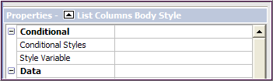

- In the Properties pane, under Color & Background:
- Double-click Background Color.
- Click Aqua and click OK.
- The background of all the list columns changes to Aqua.
- Click any of the column titles, such as CAMPUS.
- Go to the Properties pane.
- Click the Ancestor button.
- From the box that appears, click List Columns Title Style.
- Under Color & Background, double-click Background Color.
- Click Silver and click OK.
- The background of all the list column titles changes to Silver.
- Remove duplicate values:
- Click the CAMPUS column title; hold down the CTRL key.
- Click the Student_Type column title.
- Click the Group/Ungroup button.

Your work area should look like this:

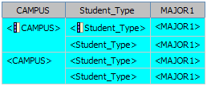
- Run the report (Term = 2008 Fall Semester, Run Date ID = Official) to see that the styling applies to all the columns.

Close the Cognos Viewer window.
Next you will see the effect of adding a new list item to your report.
- In the Source tab, expand the UDSIS Training item:
- Click College and drag it between the Student_Type and MAJOR1 columns.
- When you see the flashing black bar, release the mouse button.
Your work area will look like this:

- Run the report again (Term = 2008 Fall Semester, Run Date ID = Official).

The new item shares the styling of the other columns because styling was applied at a higher level.

- On toolbar, click the Save button to save the report.
Note: You can use this method to change any styling feature (color, alignment, font, etc.) for any report.

End of Exercise #24

Report Studio also allows you to add formatting and images to your reports. To illustrate this process, you will use the Crosstab from Scratch report you created earlier.
Exercise 25—Format a Crosstab Report

- On the Report Studio menu bar, click Open to open an existing report:
- In the Open box, click My Folders
- Scroll down to find your initials Crosstab from Scratch.

At the top left of your report (at the intersection of the rows and columns) is a space into which you have typed “College.” You can change the background color of this cell or insert objects into it. For example, if your package contains an image, you can insert it into the cell.
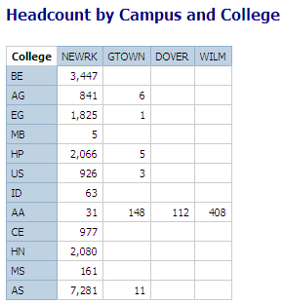
- Click inside the white space then in the Properties pane under Color & Background, double-click Background Color.
- Click the ellipses button and click Yellow. Click OK.
- Run the report (Term = 2008 Fall Semester, Run Date ID = Official).
The Cognos Viewer window should look like the one below:
- Click the Save button, in Name box, type: your initials Format Crosstab.
- Click Save.

End of Exercise #25

Report Studio Queries

In order to work with Report Studio queries, you must first understand how the program handles data and structures its queries. Report Studio begins by building a query based on the type of report and data items you select for a report.

The second aspect of the query is the Query definition. It consists of dimensions, facts, and filters. Dimensions group aspects of your information and contain hierarchical levels. For instance, when you group data in a report, data is placed into a hierarchy of levels. You are, in effect, creating a dimension. Filters eliminate groups of rows from the tabular structure before aggregates are computed.

Exercise 26—Using Query Explorer to Modify Aggregation Properties

- On the Report Studio toolbar, click the New button.

- In the New box, select List and click OK.
- On the Source tab, expand the UDSIS Training item by clicking the plus sign

- Add the following fields to your report:
  - CAMPUS
- Student_Type
- College
- MAJOR1 (in the Program folder
- COUNT_FIELD (in the Statistics folder)
- Click the title of the CAMPUS column and click the Sort button. Select Sort Descending.
- Click the title of the Student_Type column and click the Sort button. Select Sort Ascending.
- Run the report (Term = 2008 Fall Semester, Run Date ID = Official).

Notice that each row of the report has been totaled against the campus, college, and student type.

Close the Cognos Viewer window.

- In the center of the Report Studio window, move the mouse pointer over the Query Explorer icon to open it, and click Query1.

- The page has 4 frames:
  - Data Items
  - Detailed Filters
  - Summary Filters
  - Slicer
- If you examine the list in Data Items, you will notice that COUNT_FIELD has an Aggregate symbol over its icon:

It is the Auto Group & Summarize property that determines whether the Query items are grouped and aggregated. If the property is set to No, you will get details (not summaries) in your report.
- Go to the Properties pane for the Query:

- Under Data, click Auto Group & Summarize
- Change the setting to No
- Run the report again (Term = 2008 Fall Semester, Run Date ID = Official).

You are looking at individual detail rows from the database, since the grouping and aggregation have been turned off.

Clearly, this is not a desirable result. Close the Cognos Viewer window.

- In the Report Studio window:
- Move your mouse pointer over the Page Explorer bar at the center of the page.
- Click Page 1 to return to your report page.

- Click the title of the COUNT_FIELD column.
- On the toolbar, click the Aggregate button’s down-arrow.
- Click Total
Your work area shows a single total at the end of the list:

Run the report again (Term = 2008 Fall Semester, Run Date ID = Official).

- In the Cognos Viewer window, click the link to go to the end of the report.

Notice that there is a single total for the detail lines in the report—there is still no grouping because Auto Group & Summarize is set to No. Close the Cognos Viewer window.
- On the Report Studio toolbar, click the Undo button to remove the total from COUNT_FIELD. Alternatively, click on <Total(COUNT_FIELD)> in the work area and click delete.

- Next we’ll group the other columns to see how this affects the report:
- Click the title of the CAMPUS column.
- Hold down the CTRL key and click the titles of Student_Type, College and MAJOR1.
- On the toolbar, click the Group/Ungroup button.
Your work area should look like the one below:

- Run the report again (Term = 2008 Fall Semester, Run Date ID = Official).
The report should look like the one below:

This looks something like a grouped report, but since Auto Group & Summarize is set to No, we still see data for the detail rows in the report.

Click thelink a few times to see how the report is structured.

Click the link to go to the end of the report. You will see that there is no aggregation (total) on the last line. Close the Cognos Viewer window.
- Click the title of the COUNT_FIELD column then click the Aggregate button. Click Total.
- Run the report again (Term = 2008 Fall Semester, Run Date ID = Official).
  - Click the link to go to the end of the report.
  - Now there are group totals and the total for the whole report, but they are still against the un-aggregated data (detail rows).
- In the Report Studio, go to the Query Explorer bar (as in step 8 above).
Click Query1
- In the Properties pane, under Data:
Click Auto Group & Summarize to change the setting to Yes.
The Data Items will look like the one below. Note the two items for COUNT_FIELD.

- Run the report again (Term = 2008 Fall Semester, Run Date ID = Official).

- Now the groups are summarized because Auto Group & Summarize is set to Yes.

Click thelink a few times to see how the Yes setting affects the report. You will see that the rows are summarized and each level is totaled.

Click the link to go to the end of the report. You will see that there is a total on the last line (Overall - Total). Close the Cognos Viewer window.

- On the Report Studio file menu, click Save As.
- In the Save As Name box, type your initials Working with Aggregates. Click Save.

End of Exercise #26

Master-Detail Reports

In the following exercise, you will create a master report that contains information on academic career (undergrad, grad, etc.), the college each student belongs to, and the student's major. You will then create a report inside the master report that includes details for each major, including the student ID, the academic load, and grad_sustainer. You will link the two reports to create a single report. You will add filters to find only grad students in the BE college.

Exercise 27—Create a Master-Detail Report

- On the Report Studio toolbar, click the New button to create a new report.
- In the New box, select Blank and click OK.
- On the Report Studio View menu, select Visual Aids and verify that Show Boundary Lines is checked. If it is not, click to check it.
- On the Insertable Objects pane Toolbox tab, double click List and it will appear in the work area. You will see the familiar list report frame in the left table cell.
- On the Source tab, expand the UDSIS Training item, and add the following to the work area:
• ACADEMIC_CAREER
• College
• MAJOR1 (in the Program file)
- Use your knowledge of creating filters to add the following filters to your report:
[SA_DW].[UDSIS Training Extract].[LEAVE_OF_ABSENCE_FLAG]='N' [SA_DW].[UDSIS Training Extract].[ ACTIVE_STUDENT_FLAG]='Y'
[SA_DW].[UDSIS Training Extract].[ ACADEMIC_CAREER]='GRAD'
[SA_DW].[UDSIS Training Extract].[ACADEMIC_PROGRAM] like 'BE%'
Your report should look like the one below:
You will next create a second query inside the first one.
- On the Report Studio toolbar, click the Unlock button.
- On the Toolbox tab, click List. Drag it to the MAJOR1 column and drop it just after the first MAJOR1 data item (<MAJOR1>) when you see the small flashing black line.

Your work area should look like the one below:

You will next add items to the list you have just created.
- Click on the new list until the columns are all gray.
- On the Source tab, double-click the following items to add them to the new list:
• MAJOR1 (in the Program file)
• STUDENT_ID
• UD_ACADEMIC_LOAD
• GRAD_SUSTAINER
Your work area should look like the one below:
- On the Report Studio toolbar, click the Lock button.
- In the second query, click the MAJOR1 column and click Cut. Now your work area looks like the one below:
Note: Using Cut keeps the item in the report query but removes it from view. Now MAJOR1 will be listed once with the details underneath. Here is why this works: You may remember that if you cut an item in Report Studio, it remains in the Query (Query2). Thus, the data—although hidden—is still available to maintain the link between the Master and Detail queries. Even if you save and reopen the report, the item remains in the query and you can drag it back into the report at any time.

You will now link the two reports in a master-detail relationship.

- Click the title of one of the items in the second query and from the Report Studio Data menu, click Master Detail Relationships.

You will see a box like the one below:

- Click the New Link button. You will see a blue arrow between the Query1 and the Query2 panes.
- In Query1, click the MAJOR1 item. The arrow now connects MAJOR1 in both queries:
- Click OK.
- Run the report (Term = 2008 Fall Semester, Run Date ID = Official).

The Cognos Viewer window should look like the one below:
The Master-Detail report shows the MAJOR1 information combined with details for each graduate student in BE.
- On the Report Studio window File menu, click Save As.
- In the Save As Name box, type your initials Master-Detail. Click Save.

End of Exercise #27

You can also add other filters to Master-Detail reports. Suppose, for example, that you wanted to eliminate all the part-time students from your report. You can create a filter so that you will see only the information for full-time students. In the next exercise, you will add a filter to a Master-Detail report. Make sure that the Master-Detail report is still open.

Exercise 28—Add a Filter to a Master-Detail Report

- Using the same report from the previous exercise, click Save As in the File menu item.
- In the Save As Name box, type your initials Order Master-Detail Filtered. Click Save.
You will add the filter to the Detail report (Query2).
- In Query2, click the heading UD_ACADEMIC LOAD.
- Click the Filters button on the toolbar and click Edit Filters. Click the Add button. Click the Advanced radio button, and then click OK. This opens a Filters-Query2 box in which you can add an expression for the filter. You will create a filter to eliminate part-time students from your report.

- Use your knowledge of creating filters to add the following filter to your report:
[SA_DW].[UDSIS Training Extract].[UD_ACADEMIC_LOAD]='F'
- Click the Validate button to validate the expression. When the Information area reads “No Errors,” click OK.
- Run the report (Term = 2008 Fall Semester and Run Date ID = Official). It will look like the one below:
Now you will see only full-time grad students. The part-time students have been filtered out
- On the Report Studio menu, click Save to save the report.

End of Exercise #28

Create a Template

You can create a report template to be used for reports specific to your department. To do this, start with a blank report and add the components you want every report to have but do not add data from the model to the report. Save the report. When you want to use the template, open it, select Save As from the File menu, and name the new report.

In the next exercise, you will create a report template. When you finish, your template will look like the one below:

Exercise 29—Create a Report Template

- On the Report Studio toolbar, click the New button to create a new report.
- In the New box, select Blank and click OK.
- On the Report Studio menu, click arrow next to the Headers & Footers button and select Page Header & Footer.

- Click the boxes next to Header and Footer and click OK.
- Click inside the Page Header area

- In the Properties pane, under the Box category, double-click Border.
You will see a box like the one below:
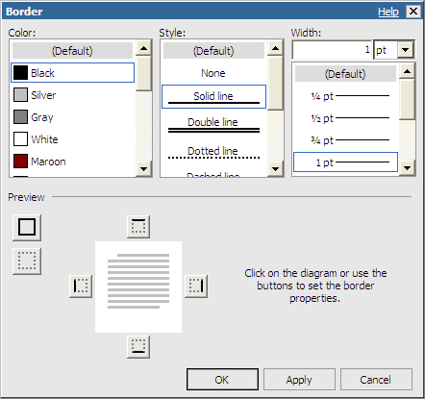

- Make these settings:
  - Color to Blue
  - Style to Solid Line
  - Width to 2px (use the drp-down under the Width box to select px and type 2 next to px).
  - Click the bottom border on the diagram
  - Click OK.
- On the Insertable Objects Toolbox tab:
  - Click the Table item and drag it into the Page Header area.
  - You will see a box like the one below:
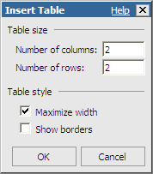
- In the Insert Table box:
  - Type 2 for the Number of columns and 2 for the Number of rows
  - Make sure the Maximize width box is checked.
  - Click OK
- On the Insertable Objects Toolbox tab:
  - Click the Text Item and drag it into the top-left table cell.
  - In the Text box, type Double-click to add text.
  - Click OK.
- Highlight the text you just added and go to the Properties pane:
  - Under the Font & Text category, double-click Font.
  - Set the Family to Arial, the Size to 14pt and the Weight to Bold.
  - Click OK.
- On the Insertable Objects Toolbox tab, click the Date item and drag it into the bottom left table cell.
- Highlight the Date item and go to the Properties pane:
  - Under the Font & Text category, double-click Font.
  - Set the Family to Arial and the Size to 12pt.
  - Click OK.
- On the Insertable Objects Toolbox tab, click the Image item and drag it into the top-right table cell.
- Click the Image item you just added and go to the Properties pane:
  - Under the URL Source category, double-click URL.
  - Use the Browse... button to set the Image URL to (Note: your package must include an image file for you to be able to do this step.).
  - Click OK.
- Click the background of the top-right table cell and go to the Properties pane:
  - Under the Font & Text category, click Horizontal Alignment.
  - Using the pull-down arrow, select Right for the alignment.
- On the Insertable Objects Toolbox tab:
  - Click the Text Item and drag it into the bottom-right table cell.
  - In the Text box, type Double-click to add Department name.
  - Click OK.
- Highlight the text you just added and go to the Properties pane:
  - Under the Font & Text category, double-click Font.
  - Set the Family to Arial, the Size to 12pt and the Weight to Bold.
  - Click OK

- Staying in the Properties pane:
  - Under the Color & Background category, double-click Foreground Color.
  - Click Blue.
  - Click OK.
- Click the background of the bottom-right table cell go to the Properties pane:
  - Under the Font & Text category, click Horizontal Alignment.
  - Using the pull-down arrow, select Right for the alignment.
This completes the Page Header. Your header will look like the one below:

Next, you will add a list frame to the Page Body.
- On the Insertable Objects Toolbox tab, click the List item and drag it into the page body. You will see the familiar List box.

Next, you will create the Page Footer.
- Click inside the Page Footer area and go to the Properties pane:
  - Under the Box category, double-click Border.
  - Set the Color to Blue.
  - Style to Solid Line.
  - Width to 2px (use the pull-down arrow under the Width box to select px and type 2 next to px).
  - Click the top border of the diagram.
  - Click OK.
- On the Insertable Objects Toolbox tab:
  - Click the Table item and drag it into the Page Footer area.
  - In the Insert Table box, type 2 for columns and 2 for rows.
  - Make sure the Maximize width box is checked.
  - Click OK.
- On the Insertable Objects Toolbox tab:
  - Click the Text Item and drag it into the top-left table cell
  - In the Text box, type University of Delaware
  - Click OK
- Highlight the text you just added and go to the Properties pane:
  - Under the Font & Text category, double-click Font.
  - Set the Family to Arial, the Size to 14pt and the Weight to Bold.
  - Click OK

- On the Insertable Objects Toolbox tab:
  - Click the Text Item and drag it into the top-right table cell
  - In the Text box, type Newark, DE 19716
  - Click OK

- Highlight the text you just added and go to the Properties pane:
  - Under the Font & Text category, double-click Font.
  - Set the Family to Arial, the Size to 14pt.
  - Click OK.

- Click the background of the top-right table cell and go to the Properties pane:
  - Under the Font & Text category, click Horizontal Alignment.
  - Using the pull-down arrow, select Right for the alignment.

- Click the bottom-left table cell then SHIFT-click the bottom right table cell. From the Report Studio Table menu, select Merge Cells .
- On the Insertable Objects Toolbox tab, click the Page Number item and drag it into the bottom table cell.

- Highlight the Page Number item and go to the Properties pane:
  - Under the Font & Text category, double-click Font.
  - Set the Family to Arial and the Size to 10pt.
  - Click OK.
- Click the background of the bottom table cell and go to the Properties pane:
  - Under the Font & Text category, click Horizontal Alignment.
  - Using the pull-down arrow, select Center for the alignment.

- Click the background of any area in your report template. On the Properties pane, click the Ancestor button and click Page.
- In the Page Properties pane:
  - Under the Box category, double-click Border.
  - Set the Color to Blue.
  - Style to Solid Line.
  - Width to 1px.
  - Click all 4 borders of the diagram.
  - Click OK.
- This completes the Page Footer. Your footer will look like the one below:

- On the Report Studio window File menu, click Save As.
- In the Save As Name box, type your initials Template. Click Save.
End of Exercise #29
You have now created a template that can be used to create other reports. When you want to use the template, open it and choose Save As from the Report Studio File menu. Give the report a new name to preserve the template.

